**Practical No. 1**

**Aim:** Create an application to demonstrate android lifecycle.

**Program:**

**Activity_main.xml**

*<?*xml version="1.0" encoding="utf-8"*?>*<androidx.constraintlayout.widget.ConstraintLayout xmlns:android="http://schemas.android.com/apk/res/android"  
 xmlns:app="http://schemas.android.com/apk/res-auto"  
 xmlns:tools="http://schemas.android.com/tools"  
 android:layout_width="match_parent"  
 android:layout_height="match_parent"  
 tools:context=".MainActivity">  
 <TextView  
 android:layout_width="wrap_content"  
 android:layout_height="wrap_content"  
 android:text="Hello World!"  
 app:layout_constraintBottom_toBottomOf="parent"  
 app:layout_constraintLeft_toLeftOf="parent"  
 app:layout_constraintRight_toRightOf="parent"  
 app:layout_constraintTop_toTopOf="parent" />  
</androidx.constraintlayout.widget.ConstraintLayout>

**MainActivity.java**

package com.example.lifecycle;  
import androidx.appcompat.app.AppCompatActivity;  
import android.os.Bundle;  
import android.util.Log;  
public class MainActivity extends AppCompatActivity {  
 @Override  
 protected void onCreate(Bundle savedInstanceState) {  
 super.onCreate(savedInstanceState);  
 setContentView(R.layout.*activity_main*);  
 Log.*d*("lifecycle","onCreate invoked");  
 }  
 @Override  
 protected void onStart() {  
 super.onStart();  
 Log.*d*("lifecycle","onStart invoked");  
 }  
 @Override  
 protected void onResume() {  
 super.onResume();  
 Log.*d*("lifecycle","onResume invoked");  
 }  
 @Override  
 protected void onPause() {  
 super.onPause();  
 Log.*d*("lifecycle","onPause invoked");  
 }  
 @Override  
 protected void onStop() {  
 super.onStop();  
 Log.*d*("lifecycle","onStop invoked");  
 }  
 @Override  
 protected void onRestart() {  
 super.onRestart();  
 Log.*d*("lifecycle","onRestart invoked");  
 }  
 @Override  
 protected void onDestroy() {  
 super.onDestroy();  
 Log.*d*("lifecycle","onDestroy invoked");  
 }  
}

**Ouptut:**

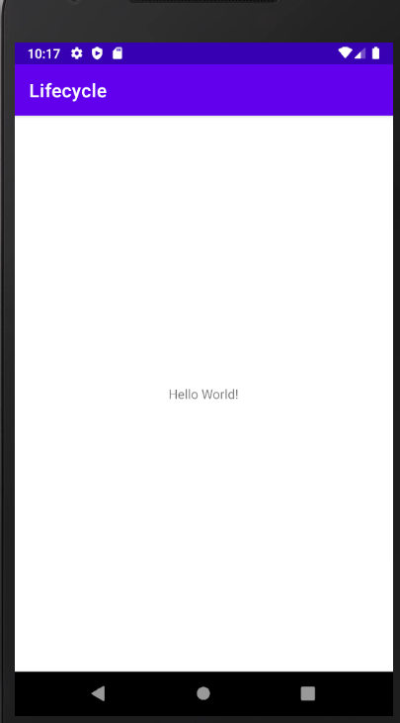

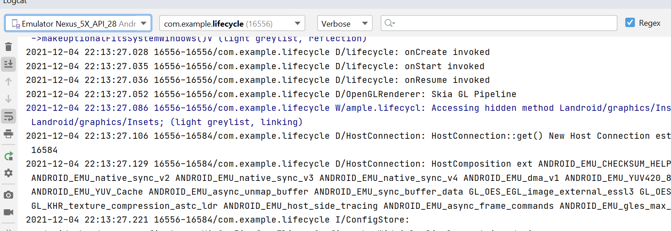

**Practical No. 2**

**Aim:** Create an application using linear layout.

**Program:**

**Activity_main.xml**

*<?*xml version="1.0" encoding="utf-8"*?>*<LinearLayout xmlns:android="http://schemas.android.com/apk/res/android"  
  
 android:layout_width="match_parent"  
 android:layout_height="match_parent"  
 android:orientation="vertical">  
  
 <EditText  
 android:layout_width="match_parent"  
 android:layout_height="wrap_content"  
 android:hint="Enter a Number"  
 android:id="@+id/edit1"/>  
  
 <EditText  
 android:layout_width="match_parent"  
 android:layout_height="wrap_content"  
 android:hint="Enter a Number"  
 android:id="@+id/edit2"/>  
  
 <Button  
 android:layout_width="match_parent"  
 android:layout_height="wrap_content"  
 android:id="@+id/btn1"  
 android:onClick="Addition"  
 android:text="Addition"/>  
 <Button  
 android:layout_width="match_parent"  
 android:layout_height="wrap_content"  
 android:id="@+id/btn2"  
 android:onClick="Subtraction"  
 android:text="Subtraction"/>  
 <Button  
 android:layout_width="match_parent"  
 android:layout_height="wrap_content"  
 android:id="@+id/btn3"  
 android:onClick="Multiplication"  
 android:text="Multiplication"/>  
 <Button  
 android:layout_width="match_parent"  
 android:layout_height="wrap_content"  
 android:id="@+id/btn4"  
 android:onClick="Division"  
 android:text="Division"/>  
  
 <TextView  
 android:layout_width="match_parent"  
 android:layout_height="wrap_content"  
 android:textSize="30dp"  
 android:id="@+id/tv1"/>  
  
</LinearLayout>

**MainActivity.java**

package com.example.calculator;  
import androidx.appcompat.app.AppCompatActivity;  
import android.os.Bundle;  
import android.view.View;  
import android.widget.EditText;  
import android.widget.TextView;  
  
public class MainActivity extends AppCompatActivity {  
 @Override  
 protected void onCreate(Bundle savedInstanceState) {  
 super.onCreate(savedInstanceState);  
 setContentView(R.layout.*activity_main*);  
 }  
 public void Addition(View v)  
 {  
 EditText e1=(EditText) findViewById(R.id.*edit1*);  
 int a=Integer.*parseInt*(e1.getText().toString());  
 EditText e2=(EditText) findViewById(R.id.*edit2*);  
 int b=Integer.*parseInt*(e2.getText().toString());  
 int c=a+b;  
 String aString = Integer.*toString*(c);  
 TextView v1=(TextView) findViewById(R.id.*tv1*);  
 v1.setText(aString);  
  
 }  
 public void Subtraction(View v)  
 {  
 EditText e1=(EditText) findViewById(R.id.*edit1*);  
 int a=Integer.*parseInt*(e1.getText().toString());  
 EditText e2=(EditText) findViewById(R.id.*edit2*);  
 int b=Integer.*parseInt*(e2.getText().toString());  
 int c=a-b;  
 String aString = Integer.*toString*(c);  
 TextView v1=(TextView) findViewById(R.id.*tv1*);  
 v1.setText(aString);  
 }  
 public void Multiplication(View v)  
 {  
 EditText e1=(EditText) findViewById(R.id.*edit1*);  
 int a=Integer.*parseInt*(e1.getText().toString());  
 EditText e2=(EditText) findViewById(R.id.*edit2*);  
 int b=Integer.*parseInt*(e2.getText().toString());  
 int c=a*b;  
 String aString = Integer.*toString*(c);  
 TextView v1=(TextView) findViewById(R.id.*tv1*);  
 v1.setText(aString);  
 }  
 public void Division(View v)  
 {  
 EditText e1=(EditText) findViewById(R.id.*edit1*);  
 int a=Integer.*parseInt*(e1.getText().toString());  
 EditText e2=(EditText) findViewById(R.id.*edit2*);  
 int b=Integer.*parseInt*(e2.getText().toString());  
 int c=a/b;  
 String aString = Integer.*toString*(c);  
 TextView v1=(TextView) findViewById(R.id.*tv1*);  
 v1.setText(aString);  
 }  
  
}

**Output:**

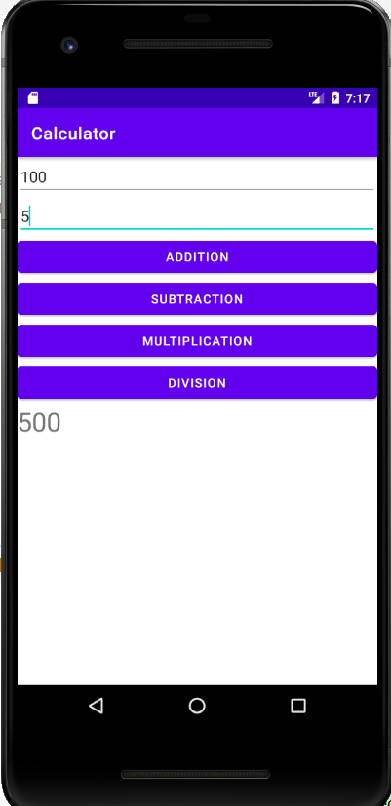

**Practical No. 3**

**Aim:** Create an application to display message in Toast.

**Program:**

**Activity_main.xml**

*<?*xml version="1.0" encoding="utf-8"*?>*<RelativeLayout xmlns:android="http://schemas.android.com/apk/res/android"  
 xmlns:app="http://schemas.android.com/apk/res-auto"  
 xmlns:tools="http://schemas.android.com/tools"  
 android:layout_width="match_parent"  
 android:layout_height="match_parent"  
 tools:context=".MainActivity">  
  
 <TextView  
 android:id="@+id/textView"  
 android:layout_width="wrap_content"  
 android:layout_height="wrap_content"  
 android:layout_alignParentTop="true"  
 android:layout_centerHorizontal="true"  
 android:layout_marginTop="41dp"  
 android:text="Registration Form"  
 android:textSize="24dp"  
 android:textStyle="bold|italic" />  
  
 <EditText  
 android:id="@+id/editTextFirst"  
 android:layout_width="wrap_content"  
 android:layout_height="wrap_content"  
 android:layout_alignParentTop="true"  
 android:layout_centerHorizontal="true"  
 android:layout_marginTop="100dp"  
 android:ems="10"  
 android:hint="Enter Your First Name"  
 android:inputType="textPersonName"  
 tools:ignore="TouchTargetSizeCheck" />  
  
 <EditText  
 android:id="@+id/editTextSecond"  
 android:layout_width="wrap_content"  
 android:layout_height="wrap_content"  
 android:layout_alignParentTop="true"  
 android:layout_centerHorizontal="true"  
 android:layout_marginTop="156dp"  
 android:ems="10"  
 android:hint="Enter Your Last Name"  
 android:inputType="textPersonName" />  
  
 <RadioGroup  
 android:id="@+id/radioGroup"  
 android:layout_width="wrap_content"  
 android:layout_height="wrap_content"  
 android:layout_marginTop="220dp"  
 android:orientation="horizontal"  
 android:layout_marginStart="100dp">  
  
 <RadioButton  
 android:id="@+id/radioFemale"  
 android:layout_width="wrap_content"  
 android:layout_height="wrap_content"  
 android:checked="false"  
 android:text=" Female"  
 android:textSize="20dp" />  
  
 <RadioButton  
 android:id="@+id/radioMale"  
 android:layout_width="wrap_content"  
 android:layout_height="wrap_content"  
 android:checked="false"  
 android:text=" Male"  
 android:textSize="20dp" />  
 </RadioGroup>  
  
 <EditText  
 android:id="@+id/editTextThird"  
 android:layout_width="wrap_content"  
 android:layout_height="wrap_content"  
 android:layout_alignParentTop="true"  
 android:layout_centerHorizontal="true"  
 android:layout_marginTop="280dp"  
 android:ems="10"  
 android:hint="Enter Your Number"  
 android:inputType="number"  
 />  
 <EditText  
 android:id="@+id/editTextFourth"  
 android:layout_width="wrap_content"  
 android:layout_height="wrap_content"  
 android:layout_alignParentTop="true"  
 android:layout_centerHorizontal="true"  
 android:layout_marginTop="330dp"  
 android:ems="10"  
 android:hint="Enter Your Location"  
 android:inputType="text"  
 />  
  
 <Button  
 android:id="@+id/button"  
 android:layout_width="wrap_content"  
 android:layout_height="wrap_content"  
 android:layout_alignParentTop="true"  
 android:layout_centerHorizontal="true"  
 android:layout_marginTop="390dp"  
 android:backgroundTint="#0A980F"  
 android:text="REGISTER" />  
  
</RelativeLayout>

**MainActivity.java**

package com.example.registration;  
import androidx.appcompat.app.AppCompatActivity;  
import android.os.Bundle;  
import android.view.View;  
import android.widget.Button;  
import android.widget.Toast;  
  
public class MainActivity extends AppCompatActivity {  
 @Override  
 protected void onCreate(Bundle savedInstanceState) {  
 super.onCreate(savedInstanceState);  
 setContentView(R.layout.*activity_main*);  
 Button b1=(Button)findViewById(R.id.*button*);  
 b1.setOnClickListener(new View.OnClickListener() {  
 @Override  
 public void onClick(View view) {  
 Toast.*makeText*(MainActivity.this,"Registration Completed.",Toast.*LENGTH_LONG*).show();  
 }  
 });  
 }  
}

**Output:**

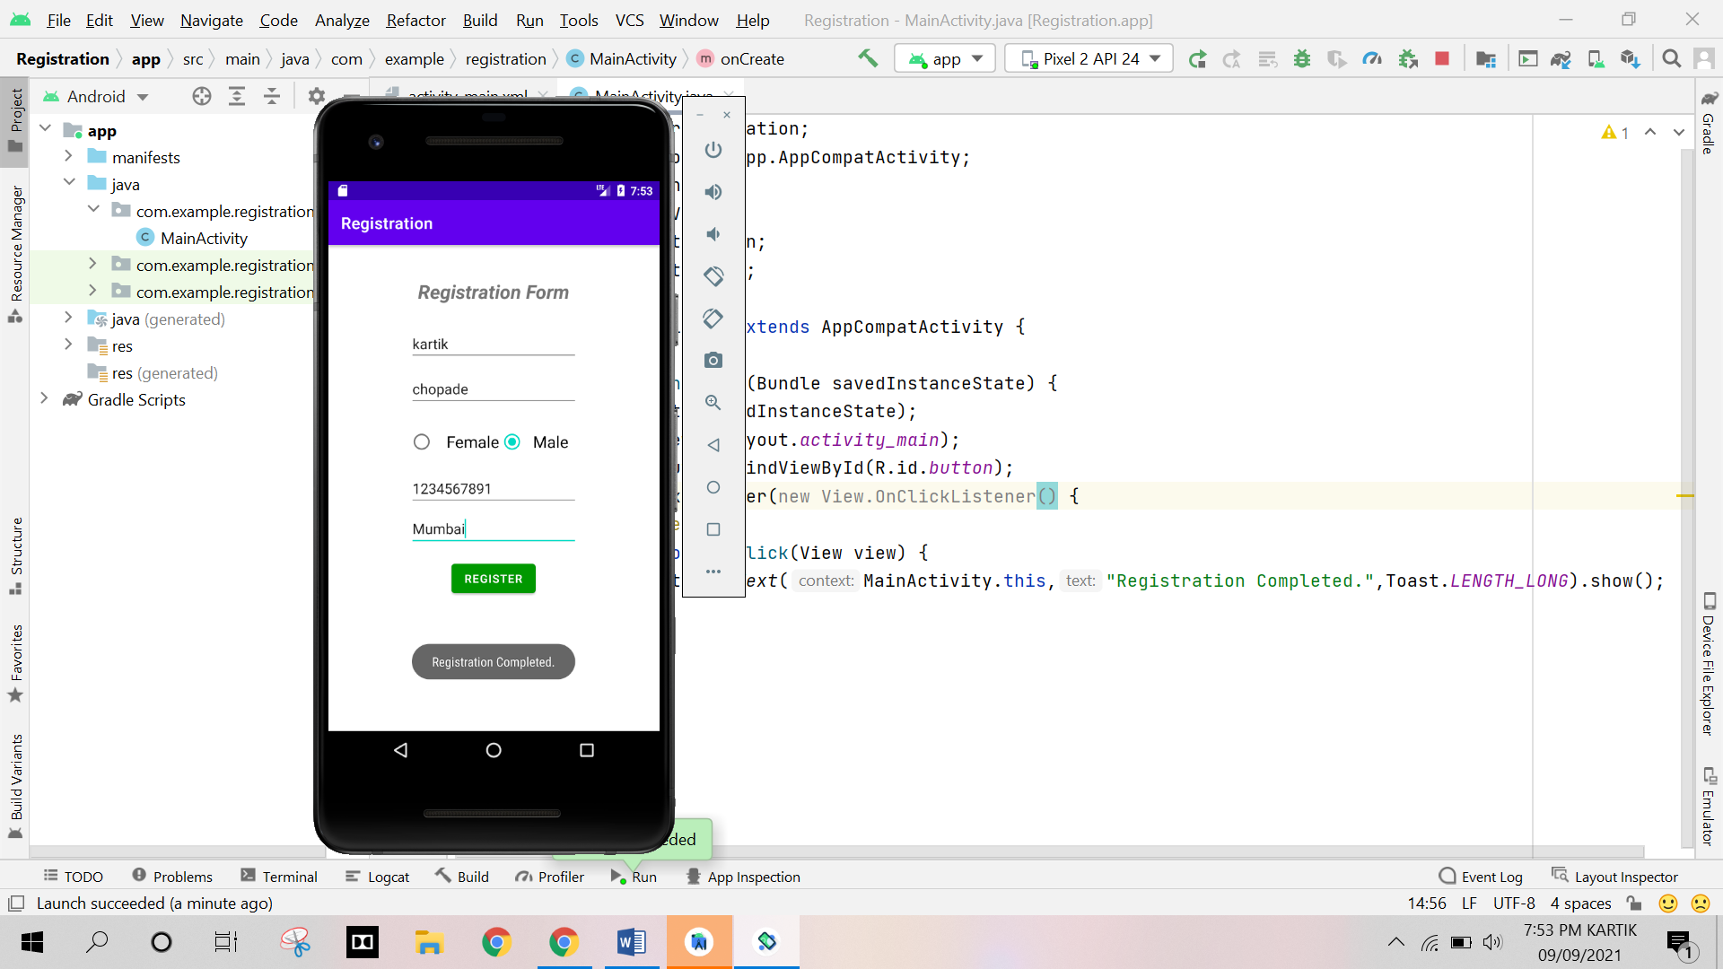

**Practical No. 4**

**Aim:** Create an application to display basic calculator.

**Program:**

**Activity_main.xml**

*<?*xml version="1.0" encoding="utf-8"*?>*<LinearLayout xmlns:android="http://schemas.android.com/apk/res/android"  
  
 android:layout_width="match_parent"  
 android:layout_height="match_parent"  
 android:orientation="vertical">  
  
 <EditText  
 android:layout_width="match_parent"  
 android:layout_height="wrap_content"  
 android:hint="Enter a Number"  
 android:id="@+id/edit1"/>  
  
 <EditText  
 android:layout_width="match_parent"  
 android:layout_height="wrap_content"  
 android:hint="Enter a Number"  
 android:id="@+id/edit2"/>  
  
 <Button  
 android:layout_width="match_parent"  
 android:layout_height="wrap_content"  
 android:id="@+id/btn1"  
 android:onClick="Addition"  
 android:text="Addition"/>  
 <Button  
 android:layout_width="match_parent"  
 android:layout_height="wrap_content"  
 android:id="@+id/btn2"  
 android:onClick="Subtraction"  
 android:text="Subtraction"/>  
 <Button  
 android:layout_width="match_parent"  
 android:layout_height="wrap_content"  
 android:id="@+id/btn3"  
 android:onClick="Multiplication"  
 android:text="Multiplication"/>  
 <Button  
 android:layout_width="match_parent"  
 android:layout_height="wrap_content"  
 android:id="@+id/btn4"  
 android:onClick="Division"  
 android:text="Division"/>  
  
 <TextView  
 android:layout_width="match_parent"  
 android:layout_height="wrap_content"  
 android:textSize="30dp"  
 android:id="@+id/tv1"/>  
  
</LinearLayout>

**MainActivity.java**

package com.example.calculator;  
import androidx.appcompat.app.AppCompatActivity;  
import android.os.Bundle;  
import android.view.View;  
import android.widget.EditText;  
import android.widget.TextView;  
  
public class MainActivity extends AppCompatActivity {  
 @Override  
 protected void onCreate(Bundle savedInstanceState) {  
 super.onCreate(savedInstanceState);  
 setContentView(R.layout.*activity_main*);  
 }  
 public void Addition(View v)  
 {  
 EditText e1=(EditText) findViewById(R.id.*edit1*);  
 int a=Integer.*parseInt*(e1.getText().toString());  
 EditText e2=(EditText) findViewById(R.id.*edit2*);  
 int b=Integer.*parseInt*(e2.getText().toString());  
 int c=a+b;  
 String aString = Integer.*toString*(c);  
 TextView v1=(TextView) findViewById(R.id.*tv1*);  
 v1.setText(aString);  
  
 }  
 public void Subtraction(View v)  
 {  
 EditText e1=(EditText) findViewById(R.id.*edit1*);  
 int a=Integer.*parseInt*(e1.getText().toString());  
 EditText e2=(EditText) findViewById(R.id.*edit2*);  
 int b=Integer.*parseInt*(e2.getText().toString());  
 int c=a-b;  
 String aString = Integer.*toString*(c);  
 TextView v1=(TextView) findViewById(R.id.*tv1*);  
 v1.setText(aString);  
 }  
 public void Multiplication(View v)  
 {  
 EditText e1=(EditText) findViewById(R.id.*edit1*);  
 int a=Integer.*parseInt*(e1.getText().toString());  
 EditText e2=(EditText) findViewById(R.id.*edit2*);  
 int b=Integer.*parseInt*(e2.getText().toString());  
 int c=a*b;  
 String aString = Integer.*toString*(c);  
 TextView v1=(TextView) findViewById(R.id.*tv1*);  
 v1.setText(aString);  
 }  
 public void Division(View v)  
 {  
 EditText e1=(EditText) findViewById(R.id.*edit1*);  
 int a=Integer.*parseInt*(e1.getText().toString());  
 EditText e2=(EditText) findViewById(R.id.*edit2*);  
 int b=Integer.*parseInt*(e2.getText().toString());  
 int c=a/b;  
 String aString = Integer.*toString*(c);  
 TextView v1=(TextView) findViewById(R.id.*tv1*);  
 v1.setText(aString);  
 }  
}

**Output:**



**Practical No. 5**

**Aim:** Create an application to demonstrate implicit and explicit intent.

**Program:**

**Activity_main.xml**

*<?*xml version="1.0" encoding="utf-8"*?>*<LinearLayout xmlns:android="http://schemas.android.com/apk/res/android"  
 android:layout_width="match_parent"  
 android:layout_height="match_parent"  
 android:orientation="vertical">  
  
 <TextView  
 android:layout_width="wrap_content"  
 android:layout_height="wrap_content"  
 android:layout_marginLeft="45dp"  
 android:layout_marginTop="50dp"  
 android:text="This is First Activity"  
 android:textSize="40dp" />  
  
 <Button  
 android:id="@+id/btn1"  
 android:layout_width="142dp"  
 android:layout_height="62dp"  
 android:layout_marginLeft="140dp"  
 android:layout_marginTop="100dp"  
 android:text="Implicit" />  
  
 <Button  
 android:id="@+id/btn2"  
 android:layout_width="151dp"  
 android:layout_height="65dp"  
 android:layout_marginLeft="140dp"  
 android:layout_marginTop="100dp"  
 android:text="Explicit" />  
</LinearLayout>

**MainActivity.java**

package com.example.practical3;  
import androidx.appcompat.app.AppCompatActivity;  
import android.content.Intent;  
import android.net.Uri;  
import android.os.Bundle;  
import android.view.View;  
import android.widget.Button;  
  
import java.net.URL;  
  
public class MainActivity extends AppCompatActivity {  
  
 @Override  
 protected void onCreate(Bundle savedInstanceState) {  
 super.onCreate(savedInstanceState);  
 setContentView(R.layout.*activity_main*);  
 Button b1=(Button) findViewById(R.id.*btn1*);  
 Button b2=(Button) findViewById(R.id.*btn2*);  
 b2.setOnClickListener(new View.OnClickListener() {  
 @Override  
 public void onClick(View view) {  
 Intent i=new Intent(MainActivity.this,SecondAct.class);  
 startActivity(i);  
 }  
 });  
 b1.setOnClickListener(new View.OnClickListener() {  
 @Override  
 public void onClick(View view) {  
 Intent intent=new Intent(Intent.*ACTION_VIEW*);  
 intent.setData(Uri.*parse*("https://www.google.com"));  
 startActivity(intent);  
 }  
 });  
 }  
}

**activity_second.xml**

*<?*xml version="1.0" encoding="utf-8"*?>*<RelativeLayout xmlns:android="http://schemas.android.com/apk/res/android"  
  
 android:layout_width="match_parent"  
 android:layout_height="match_parent"  
 android:orientation="horizontal">  
  
 <TextView  
 android:layout_marginTop="300dp"  
 android:layout_width="wrap_content"  
 android:layout_height="wrap_content"  
 android:layout_centerHorizontal="true"  
 android:text="This is Second Activity"  
 android:textSize="30dp"/>  
  
</RelativeLayout>

**SecondActivity.java**

package com.example.practical3;  
  
import androidx.appcompat.app.AppCompatActivity;  
  
import android.os.Bundle;  
  
public class SecondAct extends AppCompatActivity {  
  
 @Override  
 protected void onCreate(Bundle savedInstanceState) {  
 super.onCreate(savedInstanceState);  
 setContentView(R.layout.*activity_second*);  
 }  
}

**Output:**

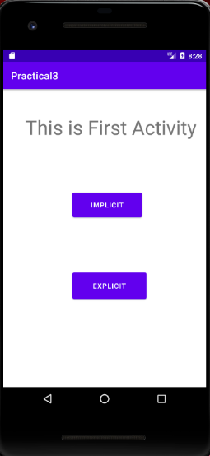

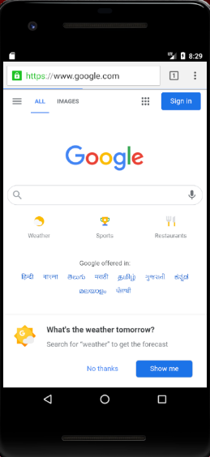

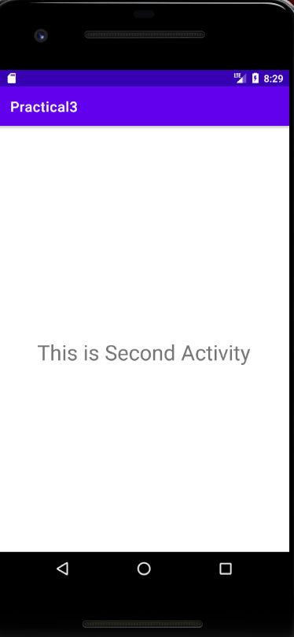

**Practical No. 6**

**Aim:** Create an application display UI component.

**Program:**

**Activity_main.xml**

*<?*xml version="1.0" encoding="utf-8"*?>*<RelativeLayout xmlns:android="http://schemas.android.com/apk/res/android"  
 xmlns:app="http://schemas.android.com/apk/res-auto"  
 xmlns:tools="http://schemas.android.com/tools"  
 android:layout_width="match_parent"  
 android:layout_height="match_parent"  
 tools:context=".MainActivity">  
  
 <TextView  
 android:id="@+id/textView"  
 android:layout_width="wrap_content"  
 android:layout_height="wrap_content"  
 android:layout_alignParentTop="true"  
 android:layout_centerHorizontal="true"  
 android:layout_marginTop="41dp"  
 android:text="Registration Form"  
 android:textSize="24dp"  
 android:textStyle="bold|italic" />  
  
 <EditText  
 android:id="@+id/editTextFirst"  
 android:layout_width="wrap_content"  
 android:layout_height="wrap_content"  
 android:layout_alignParentTop="true"  
 android:layout_centerHorizontal="true"  
 android:layout_marginTop="100dp"  
 android:ems="10"  
 android:hint="Enter Your First Name"  
 android:inputType="textPersonName"  
 tools:ignore="TouchTargetSizeCheck" />  
  
 <EditText  
 android:id="@+id/editTextSecond"  
 android:layout_width="wrap_content"  
 android:layout_height="wrap_content"  
 android:layout_alignParentTop="true"  
 android:layout_centerHorizontal="true"  
 android:layout_marginTop="156dp"  
 android:ems="10"  
 android:hint="Enter Your Last Name"  
 android:inputType="textPersonName" />  
  
 <RadioGroup  
 android:id="@+id/radioGroup"  
 android:layout_width="wrap_content"  
 android:layout_height="wrap_content"  
 android:layout_marginTop="220dp"  
 android:orientation="horizontal"  
 android:layout_marginStart="100dp">  
  
 <RadioButton  
 android:id="@+id/radioFemale"  
 android:layout_width="wrap_content"  
 android:layout_height="wrap_content"  
 android:checked="false"  
 android:text=" Female"  
 android:textSize="20dp" />  
  
 <RadioButton  
 android:id="@+id/radioMale"  
 android:layout_width="wrap_content"  
 android:layout_height="wrap_content"  
 android:checked="false"  
 android:text=" Male"  
 android:textSize="20dp" />  
 </RadioGroup>  
  
 <EditText  
 android:id="@+id/editTextThird"  
 android:layout_width="wrap_content"  
 android:layout_height="wrap_content"  
 android:layout_alignParentTop="true"  
 android:layout_centerHorizontal="true"  
 android:layout_marginTop="280dp"  
 android:ems="10"  
 android:hint="Enter Your Number"  
 android:inputType="number"  
 />  
 <EditText  
 android:id="@+id/editTextFourth"  
 android:layout_width="wrap_content"  
 android:layout_height="wrap_content"  
 android:layout_alignParentTop="true"  
 android:layout_centerHorizontal="true"  
 android:layout_marginTop="330dp"  
 android:ems="10"  
 android:hint="Enter Your Location"  
 android:inputType="text"  
 />  
  
 <Button  
 android:id="@+id/button"  
 android:layout_width="wrap_content"  
 android:layout_height="wrap_content"  
 android:layout_alignParentTop="true"  
 android:layout_centerHorizontal="true"  
 android:layout_marginTop="390dp"  
 android:backgroundTint="#0A980F"  
 android:text="REGISTER" />  
  
</RelativeLayout>

**Output:**

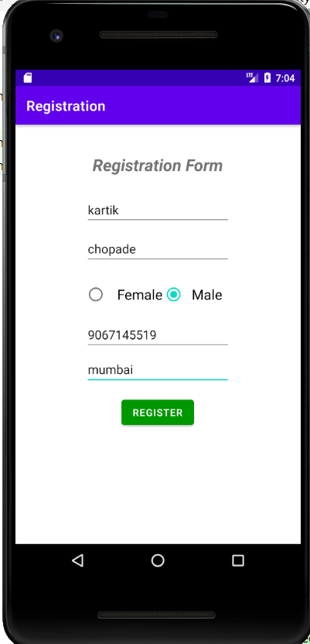

**Practical No. 7**

**Aim:** Create an application to display image using imageView.

**Program:**

**Activity_main.xml**

*<?*xml version="1.0" encoding="utf-8"*?>*<RelativeLayout xmlns:android="http://schemas.android.com/apk/res/android"  
 xmlns:app="http://schemas.android.com/apk/res-auto"  
 xmlns:tools="http://schemas.android.com/tools"  
 android:layout_width="match_parent"  
 android:layout_height="match_parent"  
 tools:context=".MainActivity">  
 <ImageView  
 android:layout_width="wrap_content"  
 android:layout_height="wrap_content"  
 android:id="@+id/imageView"  
 android:layout_centerVertical="true"  
 android:layout_centerHorizontal="true"  
 android:src="@drawable/image"/>  
</RelativeLayout>

**MainActivity.java**

package com.example.practical9;  
import androidx.appcompat.app.AppCompatActivity;  
import android.os.Bundle;  
public class MainActivity extends AppCompatActivity {  
 @Override  
 protected void onCreate(Bundle savedInstanceState) {  
 super.onCreate(savedInstanceState);  
 setContentView(R.layout.*activity_main*);  
 }  
}

**Output:**

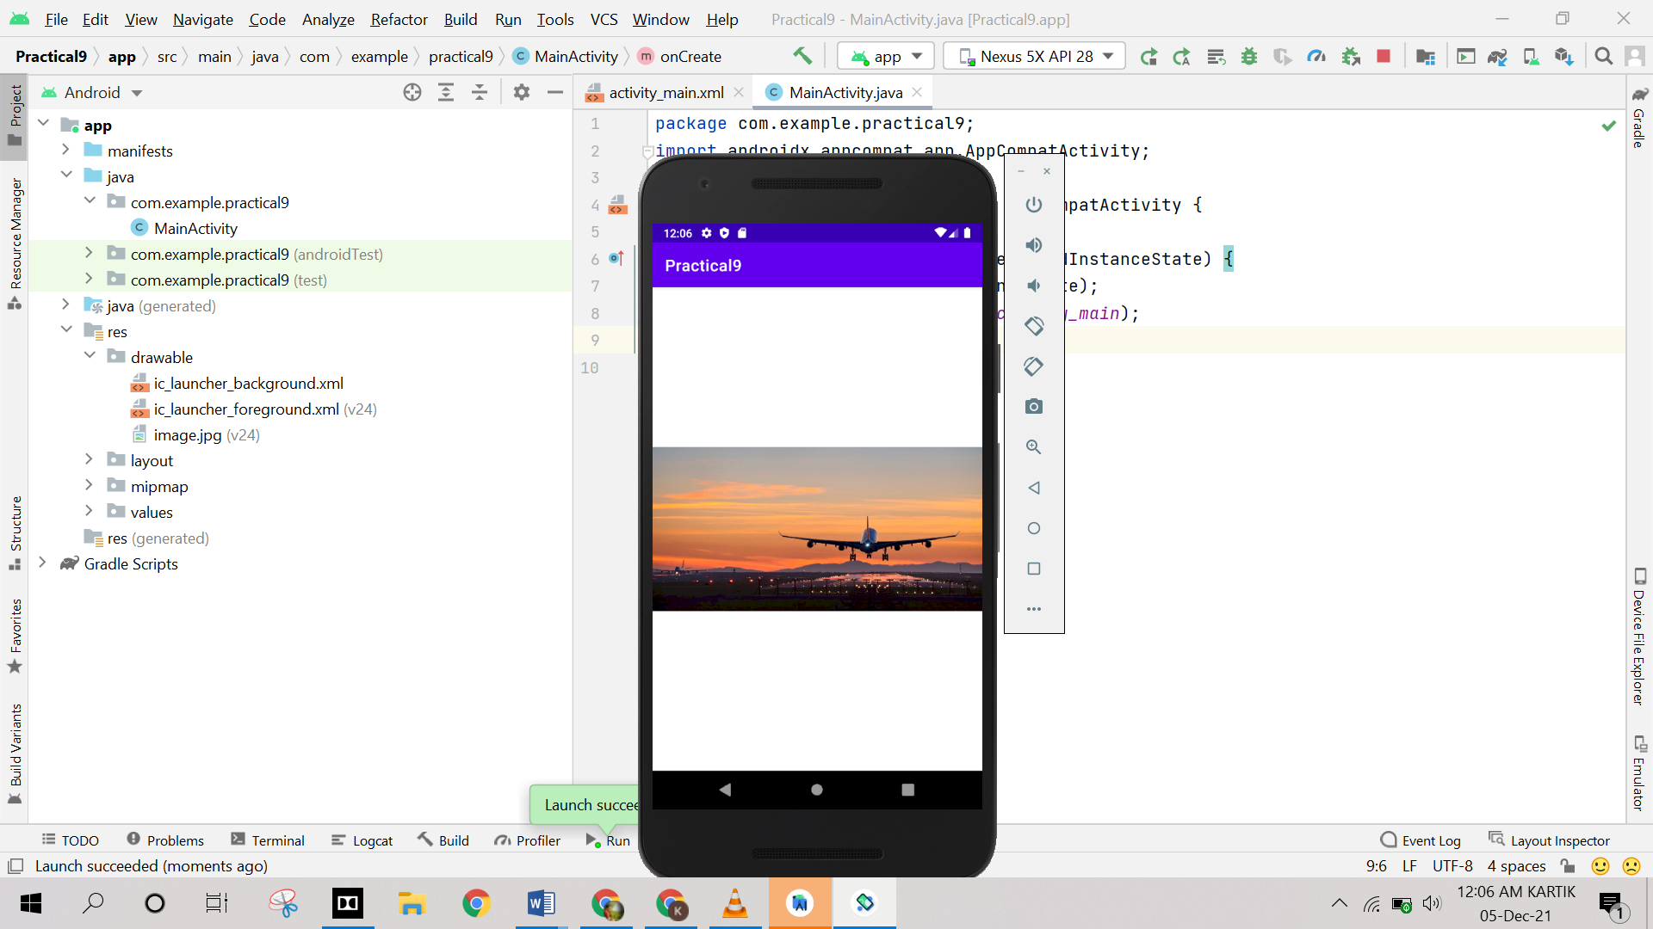

**Practical No. 8**

**Aim:** Create an application to draw 2D filled circle.

**Program:**

**Activity_main.xml**

*<?*xml version="1.0" encoding="utf-8"*?>*<androidx.constraintlayout.widget.ConstraintLayout xmlns:android="http://schemas.android.com/apk/res/android"  
 xmlns:app="http://schemas.android.com/apk/res-auto"  
 xmlns:tools="http://schemas.android.com/tools"  
 android:layout_width="match_parent"  
 android:layout_height="match_parent"  
 tools:context=".MainActivity">  
  
 <TextView  
 android:layout_width="wrap_content"  
 android:layout_height="wrap_content"  
 android:text="Hello World!"  
 app:layout_constraintBottom_toBottomOf="parent"  
 app:layout_constraintLeft_toLeftOf="parent"  
 app:layout_constraintRight_toRightOf="parent"  
 app:layout_constraintTop_toTopOf="parent" />  
  
</androidx.constraintlayout.widget.ConstraintLayout>

**MainActivity.java**

package com.example.practical_7;  
import androidx.appcompat.app.AppCompatActivity;  
import android.content.Context;  
import android.graphics.Canvas;  
import android.graphics.Color;  
import android.graphics.Paint;  
import android.os.Bundle;  
import android.view.View;  
  
public class MainActivity extends AppCompatActivity {  
  
 @Override  
 protected void onCreate(Bundle savedInstanceState) {  
 super.onCreate(savedInstanceState);  
 setContentView(new Myview(this));  
 }  
  
 public class Myview extends View {  
 public Myview(Context cont) {  
 super(cont);  
 }  
  
 protected void onDraw(Canvas canvas) {  
 super.onDraw(canvas);  
 int x = getWidth();  
 int y = getHeight();  
 int rad = 100;  
 Paint p = new Paint();  
 p.setStyle(Paint.Style.*FILL*);  
 p.setColor(Color.*WHITE*);  
 canvas.drawPaint(p);  
 p.setColor(Color.*parseColor*("#da4747"));  
 canvas.drawCircle(x / 2, y / 2, rad, p);  
 }  
 }  
}

**Output:**

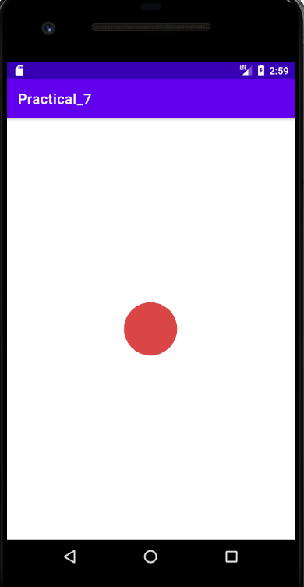

**Practical No. 9**

**Aim:** Write an application to create alert box with message and buttons.

**Program:**

**Activity_main.xml**

*<?*xml version="1.0" encoding="utf-8"*?>*<RelativeLayout xmlns:android="http://schemas.android.com/apk/res/android"  
 xmlns:app="http://schemas.android.com/apk/res-auto"  
 xmlns:tools="http://schemas.android.com/tools"  
 android:layout_width="match_parent"  
 android:layout_height="match_parent"  
 tools:context=".MainActivity">  
  
 <TextView  
 android:layout_width="match_parent"  
 android:layout_height="wrap_content"  
 android:text="Login Form"  
 android:textSize="40sp"  
 android:textStyle="bold"  
 android:gravity="center_horizontal"  
 android:layout_marginTop="50dp"/>  
  
 <EditText  
 android:id="@+id/txt1"  
 android:layout_width="wrap_content"  
 android:layout_height="wrap_content"  
 android:layout_centerHorizontal="true"  
 android:ems="10"  
 android:hint="Enter Username"  
 android:inputType="textPersonName"  
 app:layout_constraintEnd_toEndOf="parent"  
 app:layout_constraintHorizontal_bias="0.502"  
 app:layout_constraintStart_toStartOf="parent"  
 app:layout_constraintTop_toTopOf="parent"  
 android:layout_marginTop="150dp"/>  
  
 <EditText  
 android:id="@+id/txt2"  
 android:layout_width="wrap_content"  
 android:layout_height="wrap_content"  
 android:layout_centerHorizontal="true"  
 android:layout_marginTop="250dp"  
 android:ems="10"  
 android:hint="Password"  
 android:inputType="textPassword"  
 app:layout_constraintEnd_toEndOf="parent"  
 app:layout_constraintHorizontal_bias="0.502"  
 app:layout_constraintStart_toStartOf="parent"  
 app:layout_constraintTop_toBottomOf="@+id/txt1"  
 />  
 <Button  
 android:id="@+id/btn1"  
 android:layout_width="wrap_content"  
 android:layout_height="wrap_content"  
 android:layout_centerHorizontal="true"  
 android:layout_marginTop="350dp"  
 android:text="Submit"  
  
 />  
 <TextView  
 android:id="@+id/textView"  
 android:layout_width="wrap_content"  
 android:layout_height="wrap_content"  
 android:layout_centerHorizontal="true"  
 android:layout_marginTop="450dp"  
 android:text="TextView"  
 />  
  
</RelativeLayout>

**MainActivity.java**

package com.example.practical_4;  
import androidx.appcompat.app.AppCompatActivity;  
import android.os.Bundle;  
import android.content.DialogInterface;  
import android.content.Intent;  
import android.view.View;  
import android.widget.Button;  
import android.widget.EditText;  
import android.widget.TextView;  
import androidx.appcompat.app.AlertDialog;  
public class MainActivity extends AppCompatActivity {  
 Button b1;  
 EditText t1,t2;  
 int attempt_counter=3;  
 TextView attempt;  
  
  
 @Override  
 protected void onCreate(Bundle savedInstanceState) {  
 super.onCreate(savedInstanceState);  
 setContentView(R.layout.*activity_main*);  
 t1=(EditText) findViewById(R.id.*txt1*);  
 t2=(EditText) findViewById(R.id.*txt2*);  
 b1=(Button) findViewById(R.id.*btn1*);  
 attempt=(TextView) findViewById(R.id.*textView*);  
 String str="admin";  
 String str2="password";  
 b1.setOnClickListener(new View.OnClickListener() {  
 @Override  
 public void onClick(View view) {  
 if(t1.getText().toString().equals("admin") && t2.getText().toString().equals("password"))  
 {  
 open(view);  
 }  
 else  
 {  
 open1(view);  
 attempt_counter--;  
 attempt.setText(Integer.*toString*(attempt_counter));  
 if(attempt_counter == 0){  
 b1.setEnabled(false);  
 }  
 }  
 }  
 });  
 }  
 public void open(View view){  
 AlertDialog.Builder alertDialogBuilder = new AlertDialog.Builder(this);  
 alertDialogBuilder.setMessage("Are you sure,You wanted to make decision");  
 alertDialogBuilder.setPositiveButton("yes",  
 new DialogInterface.OnClickListener() {  
 @Override  
 public void onClick(DialogInterface arg0, int arg1) {  
 Intent intent=new Intent(MainActivity.this,Main2Activity.class);  
 startActivity(intent);  
 }  
 });  
 AlertDialog alertDialog = alertDialogBuilder.create();  
 alertDialog.show();  
 }  
 public void open1(View view){  
 AlertDialog.Builder alertDialogBuilder = new AlertDialog.Builder(this);  
 alertDialogBuilder.setMessage("Username and password are incorrect");  
 alertDialogBuilder.setPositiveButton("OK", new DialogInterface.OnClickListener() {  
 @Override  
 public void onClick(DialogInterface arg0, int arg1) {  
 }  
 });  
 AlertDialog alertDialog = alertDialogBuilder.create();  
 alertDialog.show();  
 }  
}

**activity_main2.xml**

*<?*xml version="1.0" encoding="utf-8"*?>*<RelativeLayout xmlns:android="http://schemas.android.com/apk/res/android"  
 xmlns:app="http://schemas.android.com/apk/res-auto"  
 xmlns:tools="http://schemas.android.com/tools"  
 android:layout_width="match_parent"  
 android:layout_height="match_parent"  
 tools:context=".Main2Activity">  
  
 <TextView  
 android:id="@+id/textView2"  
 android:layout_width="wrap_content"  
 android:layout_height="wrap_content"  
 android:text="WELCOME"  
 android:textSize="36sp"  
 app:layout_constraintBottom_toBottomOf="parent"  
 app:layout_constraintEnd_toEndOf="parent"  
 app:layout_constraintStart_toStartOf="parent"  
 app:layout_constraintTop_toTopOf="parent" />  
</RelativeLayout>

**Main2Activity.java**

package com.example.practical_4;  
import androidx.appcompat.app.AppCompatActivity;  
import android.os.Bundle;  
  
public class Main2Activity extends AppCompatActivity {  
  
 @Override  
 protected void onCreate(Bundle savedInstanceState) {  
 super.onCreate(savedInstanceState);  
 setContentView(R.layout.*activity_main2*);  
 }  
}

**Output:**

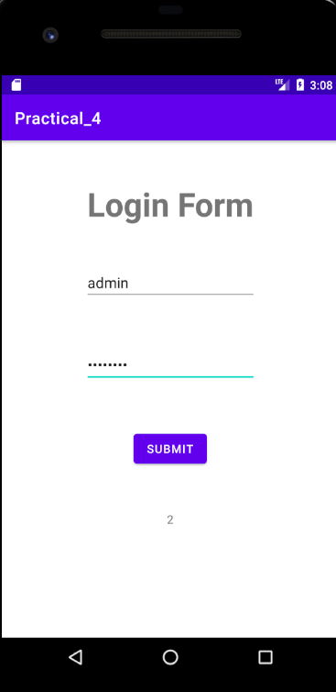

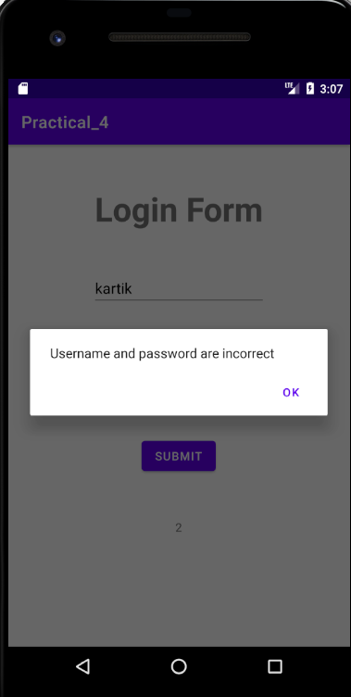



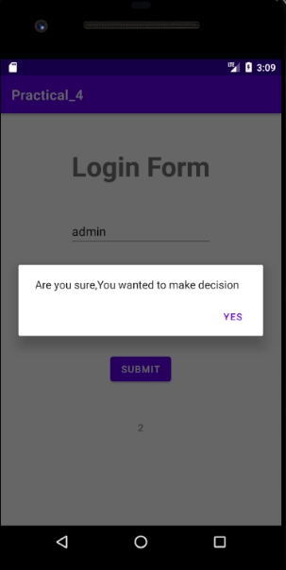

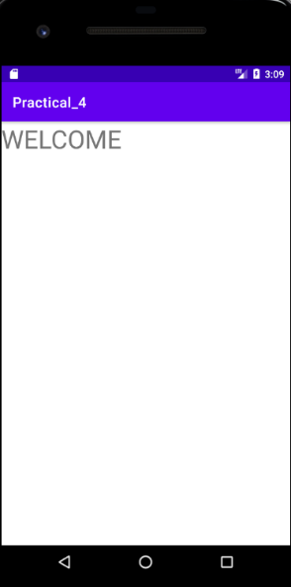

**Practical No. 10**

**Aim:** Create an application to CRUD operation in files.

**Program:**

**Activity_main.xml**

*<?*xml version="1.0" encoding="utf-8"*?>*<RelativeLayout xmlns:android="http://schemas.android.com/apk/res/android"  
 xmlns:app="http://schemas.android.com/apk/res-auto"  
 xmlns:tools="http://schemas.android.com/tools"  
 android:layout_width="match_parent"  
 android:layout_height="match_parent"  
 tools:context=".MainActivity">  
 <EditText  
 android:id="@+id/textcontent"  
 android:layout_width="match_parent"  
 android:layout_height="wrap_content"  
 android:layout_marginTop="20dp"  
 android:hint="Enter Name "  
 android:textSize="25dp"  
 android:inputType="textPersonName" />  
 <Button  
 android:id="@+id/btnwrite"  
 android:layout_width="match_parent"  
 android:layout_height="wrap_content"  
 android:text="Write"  
 android:layout_marginTop="100dp"  
 android:textSize="30sp"/>  
 <Button  
 android:id="@+id/btnread"  
 android:layout_width="match_parent"  
 android:layout_height="wrap_content"  
 android:text="Read"  
 android:textSize="30sp"  
 android:layout_marginTop="200dp"/>  
 <TextView  
 android:id="@+id/textview"  
 android:layout_width="match_parent"  
 android:layout_height="wrap_content"  
 android:text="TextView"  
 android:textSize="30sp"  
 android:layout_marginTop="300dp"/>  
 <Button  
 android:id="@+id/btnclear"  
 android:layout_width="match_parent"  
 android:layout_height="wrap_content"  
 android:layout_marginTop="400dp"  
 android:text="Clear"  
 android:onClick="clearFile"  
 android:textSize="30dp"/>  
 <Button  
 android:id="@+id/btn_delete"  
 android:layout_width="match_parent"  
 android:layout_height="wrap_content"  
 android:text="Delete"  
 android:layout_marginTop="500dp"  
 android:onClick="deleteFile"  
 android:textSize="30sp"/>  
</RelativeLayout>

**MainActivity.java**

package com.example.fileprogram;  
import androidx.appcompat.app.AppCompatActivity;  
import android.content.Context;  
import android.os.Bundle;  
import android.view.View;  
import android.widget.Button;  
import android.widget.EditText;  
import android.widget.TextView;  
import android.widget.Toast;  
import java.io.File;  
import java.io.FileInputStream;  
import java.io.FileOutputStream;  
public class MainActivity extends AppCompatActivity {  
 EditText et_Text;  
 Button b_read,b_write,b_delete;  
 TextView tv_Text;  
 String file_name="kartik.txt";  
 @Override  
 protected void onCreate(Bundle savedInstanceState) {  
 super.onCreate(savedInstanceState);  
 setContentView(R.layout.*activity_main*);  
 et_Text=(EditText) findViewById(R.id.*textcontent*);  
 b_read=(Button) findViewById(R.id.*btnread*);  
 b_write=(Button) findViewById(R.id.*btnwrite*);  
 tv_Text=(TextView) findViewById(R.id.*textview*);  
 b_delete=(Button) findViewById(R.id.*btn_delete*);  
 b_read.setOnClickListener(new View.OnClickListener() {  
 @Override  
 public void onClick(View view) {  
 tv_Text.setText(readFile(file_name));  
 }  
 });  
 b_write.setOnClickListener(new View.OnClickListener() {  
 @Override  
 public void onClick(View view) {  
 saveFile(file_name,et_Text.getText().toString());  
 Toast.*makeText*(MainActivity.this, "Saved Text", Toast.*LENGTH_SHORT*).show();  
 }  
 });  
 }  
 public void saveFile(String file_name,String text)  
 {  
 try{  
 FileOutputStream fos=openFileOutput(file_name, Context.*MODE_PRIVATE*);  
 fos.write(text.getBytes());  
 fos.close();  
 Toast.*makeText*(MainActivity.this,"",Toast.*LENGTH_SHORT*).show();  
 }  
 catch(Exception e){  
 e.printStackTrace();  
 Toast.*makeText*(MainActivity.this,"Error saving file",Toast.*LENGTH_SHORT*).show();  
  
 }  
 }  
 public String readFile(String file_name)  
 {  
 String text="";  
 try{  
 FileInputStream fis=openFileInput(file_name);  
 int size=fis.available();  
 byte[] buffer=new byte[size];  
 fis.read(buffer);  
 fis.close();  
 text=new String(buffer);  
 }  
 catch (Exception e)  
 {  
 e.printStackTrace();  
 Toast.*makeText*(MainActivity.this,"Error Read file",Toast.*LENGTH_SHORT*).show();  
 }  
 return text;  
 }  
 public void clearFile(View view){  
 et_Text.getText().clear();  
 }  
 public void deleteFile(View view)  
 {  
 File file=new File(getFilesDir(),file_name);  
 if(file.exists())  
 {  
 file.delete();  
*// deleteFile(filename);* Toast.*makeText*(MainActivity.this,"file Deleted",Toast.*LENGTH_SHORT*).show();  
 }  
 else  
 {  
 Toast.*makeText*(MainActivity.this,"file not found",Toast.*LENGTH_SHORT*).show();  
 }  
 }}

**Output:**

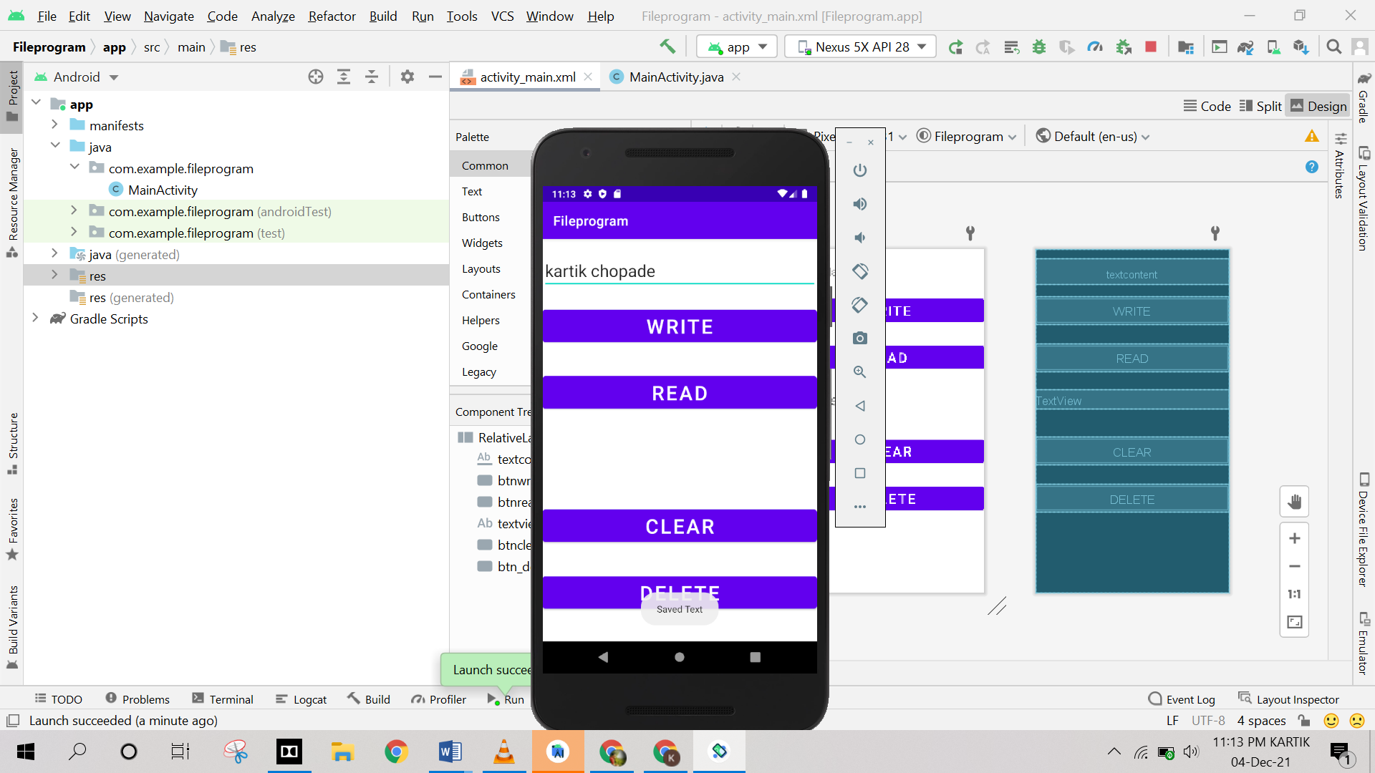

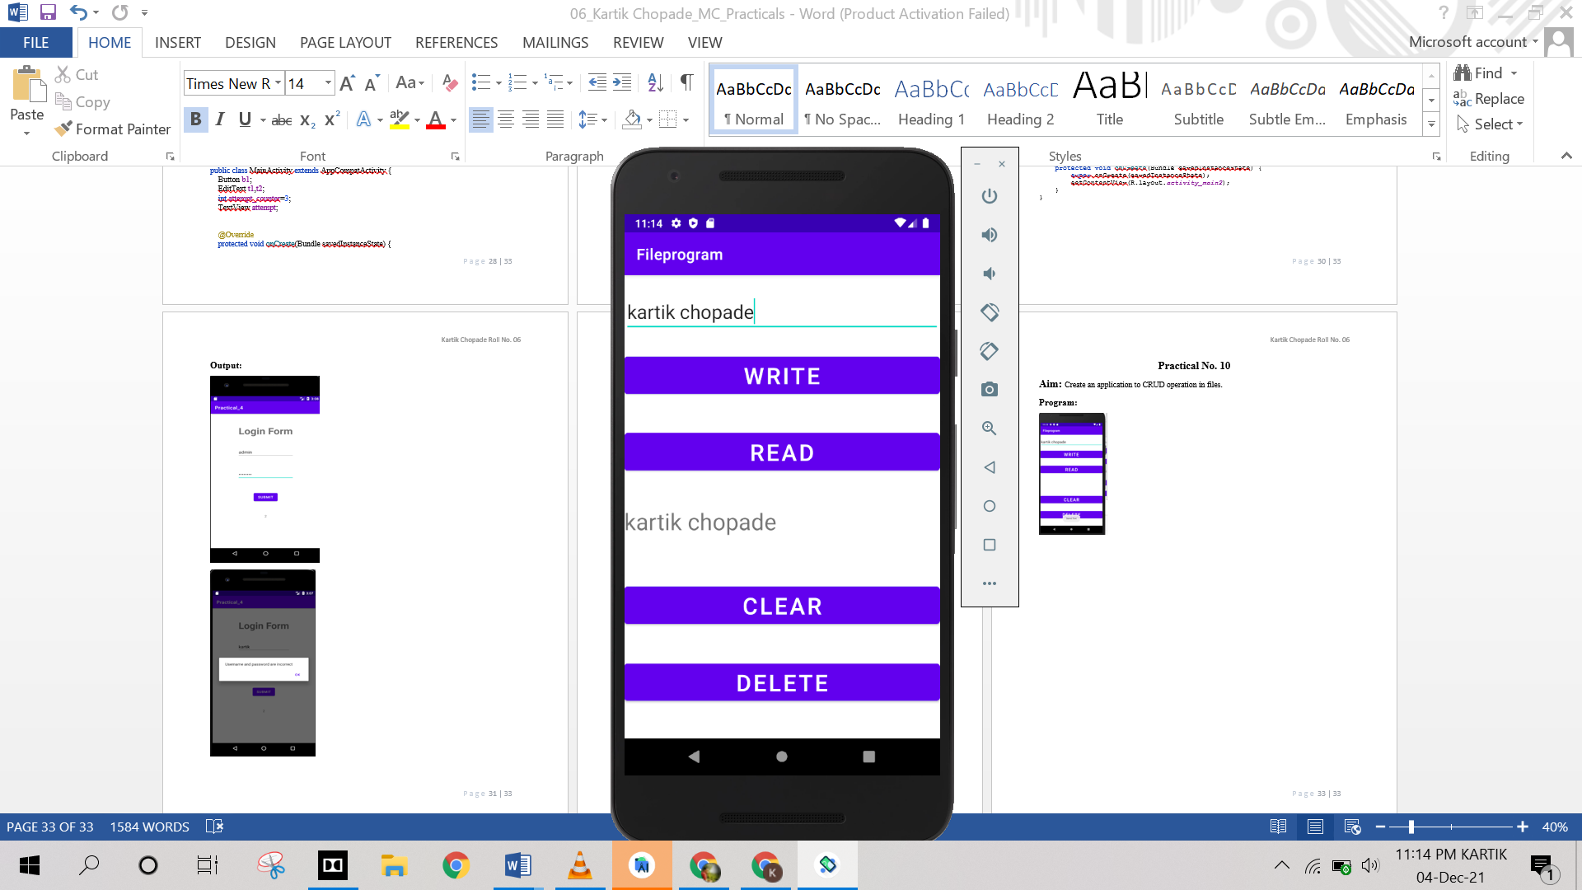

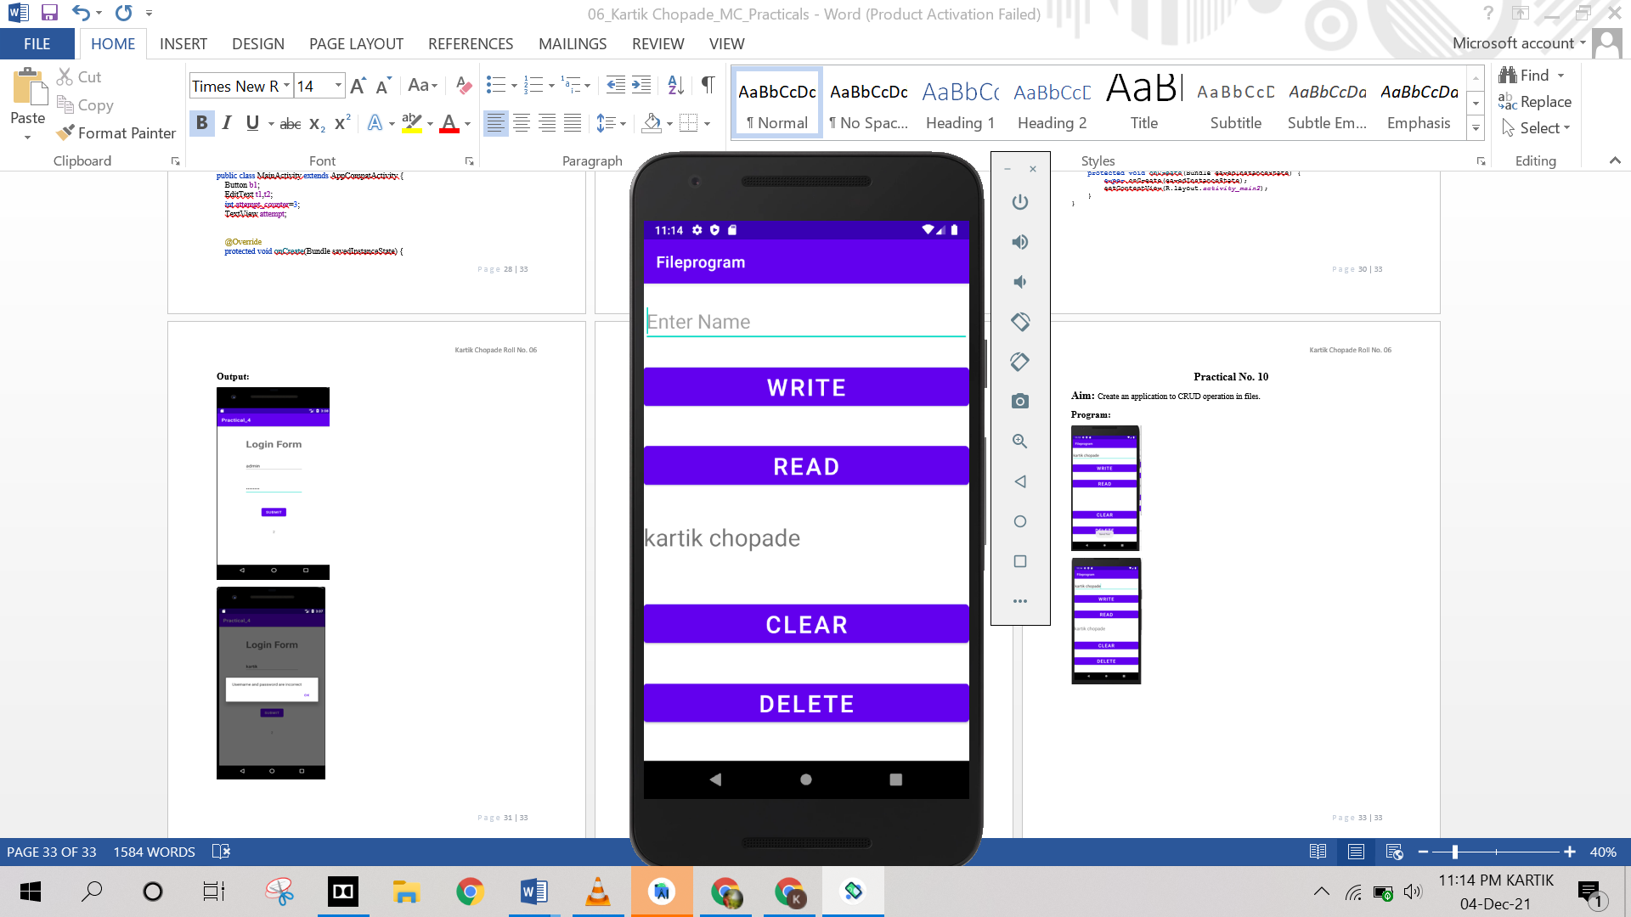

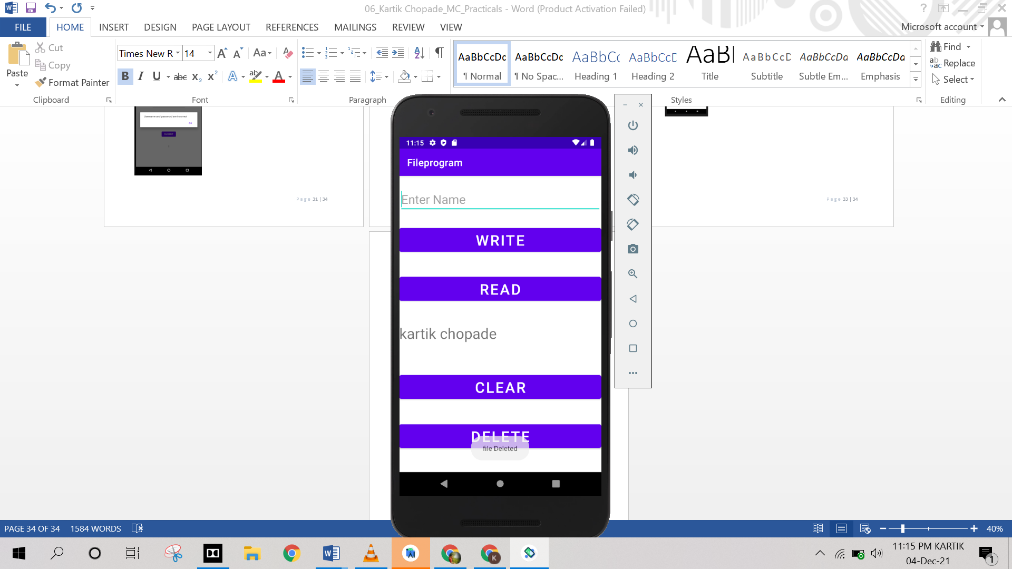

**Practical No. 11**

**Aim:** Write an application to switch on and off wifi.

**Program:**

**AndroidManifiest.xml**

*<?*xml version="1.0" encoding="utf-8"*?>*<manifest xmlns:android="http://schemas.android.com/apk/res/android"  
 package="com.example.wifi_enable_disable">  
 <uses-permission android:name="android.permission.ACCESS_WIFI_STATE">  
 </uses-permission>  
 <uses-permission android:name="android.permission.CHANGE_WIFI_STATE">  
 </uses-permission>  
 <application  
 android:allowBackup="true"  
 android:icon="@mipmap/ic_launcher"  
 android:label="@string/app_name"  
 android:roundIcon="@mipmap/ic_launcher_round"  
 android:supportsRtl="true"  
 android:theme="@style/Theme.Wifi_Enable_Disable">  
 <activity  
 android:name=".MainActivity"  
 android:exported="true">  
 <intent-filter>  
 <action android:name="android.intent.action.MAIN" />  
  
 <category android:name="android.intent.category.LAUNCHER" />  
 </intent-filter>  
 </activity>  
 </application>  
</manifest>

**Activity_main.xml**

*<?*xml version="1.0" encoding="utf-8"*?>*<androidx.constraintlayout.widget.ConstraintLayout xmlns:android="http://schemas.android.com/apk/res/android"  
 xmlns:app="http://schemas.android.com/apk/res-auto"  
 xmlns:tools="http://schemas.android.com/tools"  
 android:layout_width="match_parent"  
 android:layout_height="match_parent"  
 tools:context=".MainActivity">  
 <TextView  
 android:id="@+id/tv1"  
 android:layout_width="339dp"  
 android:layout_height="74dp"  
 android:text="WIFI Enable/Disable"  
 android:textSize="36sp"  
 app:layout_constraintBottom_toBottomOf="parent"  
 app:layout_constraintLeft_toLeftOf="parent"  
 app:layout_constraintRight_toRightOf="parent"  
 app:layout_constraintTop_toTopOf="parent"  
 app:layout_constraintVertical_bias="0.114" />  
 <Button  
 android:id="@+id/b1"  
 android:layout_width="123dp"  
 android:layout_height="75dp"  
 android:onClick="isWifi_off"  
 android:text="OFF"  
 android:textSize="36sp"  
 app:layout_constraintBottom_toBottomOf="parent"  
 app:layout_constraintEnd_toEndOf="parent"  
 app:layout_constraintHorizontal_bias="0.498"  
 app:layout_constraintStart_toStartOf="parent"  
 app:layout_constraintTop_toTopOf="parent"  
 app:layout_constraintVertical_bias="0.308" />  
 <Button  
 android:id="@+id/b2"  
 android:layout_width="122dp"  
 android:layout_height="76dp"  
 android:onClick="isWifi_on"  
 android:text="ON"  
 android:textSize="36sp"  
 app:layout_constraintBottom_toBottomOf="parent"  
 app:layout_constraintEnd_toEndOf="parent"  
 app:layout_constraintHorizontal_bias="0.498"  
 app:layout_constraintStart_toStartOf="parent"  
 app:layout_constraintTop_toTopOf="parent"  
 app:layout_constraintVertical_bias="0.441" />  
</androidx.constraintlayout.widget.ConstraintLayout>

**MainActivity.java**

package com.example.wifi_enable_disable;  
  
import androidx.appcompat.app.AppCompatActivity;  
import android.content.Context;  
import android.net.wifi.WifiManager;  
import android.os.Bundle;  
import android.view.View;  
  
public class MainActivity extends AppCompatActivity {  
 private WifiManager wifiManager;  
  
 @Override  
 protected void onCreate(Bundle savedInstanceState) {  
 super.onCreate(savedInstanceState);  
 setContentView(R.layout.*activity_main*);  
 wifiManager=(WifiManager)getApplicationContext( ).getSystemService(Context.*WIFI_SERVICE*);  
 }  
 public void isWifi_on(View view)  
 {  
 wifiManager.setWifiEnabled(true);  
 }  
  
 public void isWifi_off(View view)  
 {  
 wifiManager.setWifiEnabled(false);  
 }  
}

**Output:**

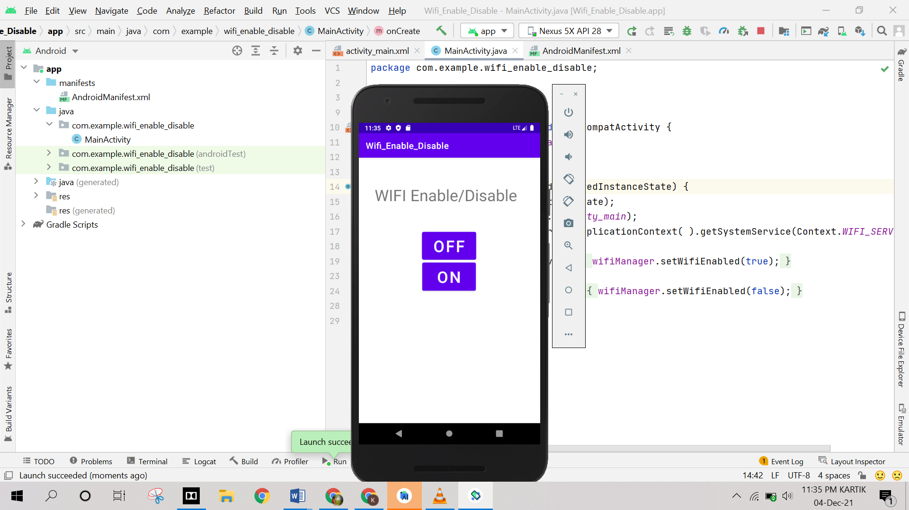

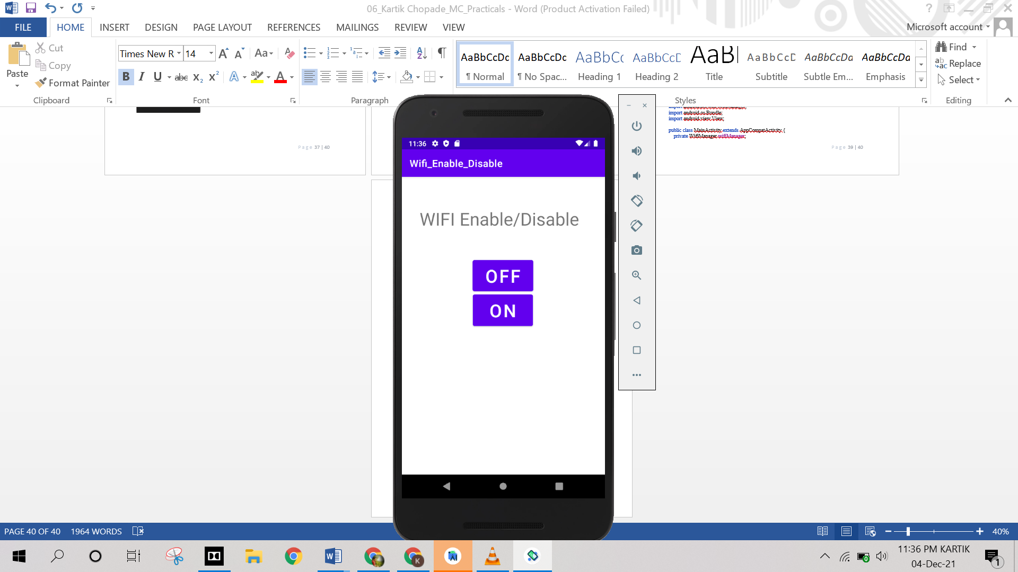

**Practical No. 12**

**Aim:** Create an application to switch an and off Bluetooth.

**Program:**

**AndroidManifiest.xml**

*<?*xml version="1.0" encoding="utf-8"*?>*<manifest xmlns:android="http://schemas.android.com/apk/res/android"  
 package="com.example.bluetooth_enable_disable">  
 <uses-permission android:name="android.permission.BLUETOOTH"></uses-permission>  
 <uses-permission android:name="android.permission.BLUETOOTH_ADMIN"></uses-permission>  
 <uses-permission android:name="android.permission.BLUETOOTH_CONNECT" />  
 <application  
 android:allowBackup="true"  
 android:icon="@mipmap/ic_launcher"  
 android:label="@string/app_name"  
 android:roundIcon="@mipmap/ic_launcher_round"  
 android:supportsRtl="true"  
 android:theme="@style/Theme.Bluetooth_Enable_Disable">  
 <activity  
 android:name=".MainActivity"  
 android:exported="true">  
 <intent-filter>  
 <action android:name="android.intent.action.MAIN" />  
 <category android:name="android.intent.category.LAUNCHER" />  
 </intent-filter>  
 </activity>  
 </application>  
  
</manifest>

**Activity_main.xml**

*<?*xml version="1.0" encoding="utf-8"*?>*<RelativeLayout xmlns:android="http://schemas.android.com/apk/res/android"  
 xmlns:app="http://schemas.android.com/apk/res-auto"  
 xmlns:tools="http://schemas.android.com/tools"  
 android:layout_width="match_parent"  
 android:layout_height="match_parent"  
 tools:context=".MainActivity">  
 <Button  
 android:id="@+id/btnOn"  
 android:layout_width="120dp"  
 android:layout_height="wrap_content"  
 android:layout_centerHorizontal="true"  
 android:layout_marginStart="72dp"  
 android:layout_marginLeft="72dp"  
 android:layout_marginTop="152dp"  
 android:text="ON"  
 android:textSize="18sp"  
 app:layout_constraintStart_toStartOf="parent"  
 app:layout_constraintTop_toTopOf="parent" />  
 <Button  
 android:id="@+id/btnOff"  
 android:layout_width="107dp"  
 android:layout_height="wrap_content"  
 android:layout_marginStart="8dp"  
 android:layout_marginTop="152dp"  
 android:layout_marginEnd="8dp"  
 android:text="OFF"  
 android:textSize="18sp"  
 app:layout_constraintEnd_toEndOf="parent"  
 app:layout_constraintHorizontal_bias="0.6"  
 app:layout_constraintStart_toEndOf="@+id/btnOn"  
 app:layout_constraintTop_toTopOf="parent" />  
</RelativeLayout>

**MainActivity.java**

package com.example.bluetooth_enable_disable;  
  
import androidx.appcompat.app.AppCompatActivity;  
import android.bluetooth.BluetoothAdapter;  
import android.content.Intent;  
import android.os.Bundle;  
import android.view.View;  
import android.widget.Button;  
import android.widget.Toast;  
  
public class MainActivity extends AppCompatActivity {  
 Button b1,b2;  
 BluetoothAdapter bluetoothAdapter=BluetoothAdapter.*getDefaultAdapter*();  
 *//private static final int REQUEST_ENABLE_BT = 1;* @Override  
 protected void onCreate(Bundle savedInstanceState) {  
 super.onCreate(savedInstanceState);  
 setContentView(R.layout.*activity_main*);  
 b1=(Button)findViewById(R.id.*btnOn*);  
 b2=(Button)findViewById(R.id.*btnOff*);  
 b1.setOnClickListener(new View.OnClickListener() {  
 @Override  
 public void onClick(View v) {  
 if(bluetoothAdapter==null)  
 {  
 Toast.*makeText*(getApplicationContext(),"Bluetooth not supported",Toast.*LENGTH_SHORT*).show();  
 }  
 else  
 {  
 if(!bluetoothAdapter.isEnabled())  
 {  
*// startActivityForResult(new Intent(BluetoothAdapter.ACTION_REQUEST_ENABLE),1);* Intent enableBtIntent = new Intent(BluetoothAdapter.*ACTION_REQUEST_ENABLE*);  
 startActivityForResult(enableBtIntent, 0);  
 Toast.*makeText*(getApplicationContext(),"Bluetooth Turned ON",Toast.*LENGTH_SHORT*).show();  
 }  
 }  
 }  
 });  
 b2.setOnClickListener(new View.OnClickListener() {  
 @Override  
 public void onClick(View v) {  
 bluetoothAdapter.disable();  
 Toast.*makeText*(getApplicationContext(),"Bluetooth Turned Off",Toast.*LENGTH_SHORT*).show();  
 }  
 });  
 }  
  
}

**Output:**

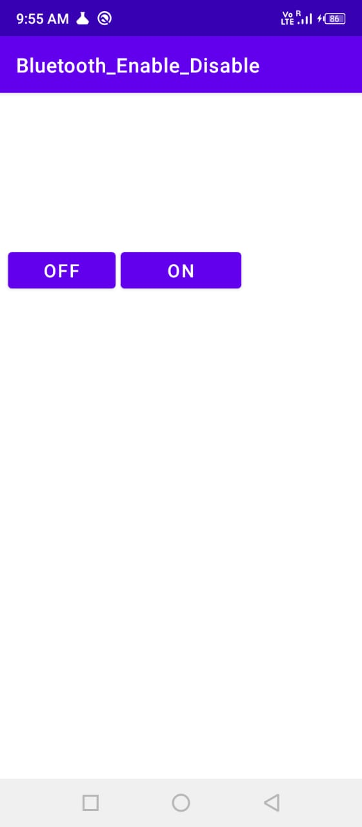

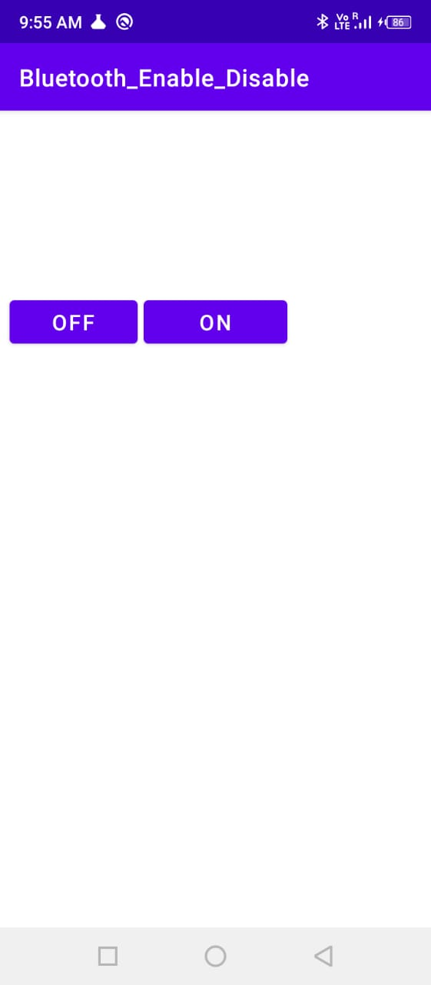

**Practical No. 13**

**Aim:** Create application to CRUD operations in SQLite.

**Program:**

**Activity_main.xml**

*<?*xml version="1.0" encoding="utf-8"*?>*<RelativeLayout xmlns:android="http://schemas.android.com/apk/res/android"  
 xmlns:app="http://schemas.android.com/apk/res-auto"  
 xmlns:tools="http://schemas.android.com/tools"  
 android:layout_width="match_parent"  
 android:layout_height="match_parent"  
 tools:context=".MainActivity">  
 <Button  
 android:id="@+id/btnselect"  
 android:layout_width="wrap_content"  
 android:layout_height="wrap_content"  
 android:layout_alignParentStart="true"  
 android:layout_alignParentLeft="true"  
 android:layout_alignParentBottom="true"  
 android:layout_marginStart="50dp"  
 android:layout_marginLeft="50dp"  
 android:layout_marginBottom="201dp"  
 android:text="View" />  
 <Button  
 android:id="@+id/btnsave"  
 android:layout_width="wrap_content"  
 android:layout_height="wrap_content"  
 android:layout_alignBottom="@+id/btnselect"  
 android:layout_alignParentEnd="true"  
 android:layout_alignParentRight="true"  
 android:layout_marginEnd="69dp"  
 android:layout_marginRight="69dp"  
 android:layout_marginBottom="0dp"  
 android:text="Save" />  
 <Button  
 android:id="@+id/btnupdate"  
 android:layout_width="wrap_content"  
 android:layout_height="wrap_content"  
 android:layout_alignStart="@+id/btnselect"  
 android:layout_alignParentBottom="true"  
 android:layout_marginStart="-7dp"  
 android:layout_marginBottom="72dp"  
 android:text="Update" />  
  
 <Button  
 android:id="@+id/btnselectperticular"  
 android:layout_width="104dp"  
 android:layout_height="71dp"  
 android:layout_below="@+id/editTextMessage"  
 android:layout_marginLeft="150dp"  
 android:layout_marginTop="160dp"  
 android:text="Search" />  
  
 <Button  
 android:id="@+id/btndel"  
 android:layout_width="102dp"  
 android:layout_height="wrap_content"  
 android:layout_below="@+id/btnsave"  
 android:layout_alignParentStart="true"  
 android:layout_alignParentLeft="true"  
 android:layout_alignParentEnd="true"  
 android:layout_alignParentRight="true"  
 android:layout_alignParentBottom="true"  
 android:layout_marginStart="240dp"  
 android:layout_marginLeft="240dp"  
 android:layout_marginTop="79dp"  
 android:layout_marginEnd="42dp"  
 android:layout_marginRight="42dp"  
 android:layout_marginBottom="74dp"  
 android:text="Delete" />  
 <EditText  
 android:id="@+id/editTextSearch"  
 android:layout_width="wrap_content"  
 android:layout_height="wrap_content"  
 android:layout_alignParentStart="true"  
 android:layout_alignParentLeft="true"  
 android:layout_alignParentTop="true"  
 android:layout_marginStart="68dp"  
 android:layout_marginLeft="68dp"  
 android:layout_marginTop="54dp"  
 android:ems="10"  
 android:hint="Search"  
 android:inputType="textPersonName"  
 android:text="" />  
 <EditText  
 android:id="@+id/editTextEmailAddress"  
 android:layout_width="wrap_content"  
 android:layout_height="wrap_content"  
 android:layout_alignParentStart="true"  
 android:layout_alignParentLeft="true"  
 android:layout_alignParentTop="true"  
 android:layout_marginStart="67dp"  
 android:layout_marginLeft="67dp"  
 android:layout_marginTop="145dp"  
 android:ems="10"  
 android:hint="Enter Your EmailAddress"  
 android:inputType="textPersonName"  
 android:text="" />  
 <EditText  
 android:id="@+id/editTextMessage"  
 android:layout_width="wrap_content"  
 android:layout_height="wrap_content"  
 android:layout_alignParentStart="true"  
 android:layout_alignParentLeft="true"  
 android:layout_alignParentTop="true"  
 android:layout_marginStart="67dp"  
 android:layout_marginLeft="67dp"  
 android:layout_marginTop="196dp"  
 android:ems="10"  
 android:hint="Enter Your Message"  
 android:inputType="textPersonName"  
 android:text="" />  
 <EditText  
 android:id="@+id/editTextName"  
 android:layout_width="wrap_content"  
 android:layout_height="wrap_content"  
 android:layout_alignParentStart="true"  
 android:layout_alignParentLeft="true"  
 android:layout_alignParentTop="true"  
 android:layout_marginStart="69dp"  
 android:layout_marginLeft="69dp"  
 android:layout_marginTop="99dp"  
 android:ems="10"  
 android:hint="Enter Your Name"  
 android:inputType="textPersonName"  
 android:text="" />  
 <TextView  
 android:id="@+id/textView5"  
 android:layout_width="wrap_content"  
 android:layout_height="wrap_content"  
 android:layout_alignParentStart="true"  
 android:layout_alignParentLeft="true"  
 android:layout_alignParentTop="true"  
 android:layout_marginStart="122dp"  
 android:layout_marginLeft="122dp"  
 android:layout_marginTop="24dp"  
 android:text="Contact Us"  
 android:textColor="@color/purple_500"  
 android:textSize="18sp"  
 android:textStyle="bold"  
 app:fontFamily="serif" />  
</RelativeLayout>

**MainActivity.java**

package com.example.practical_5;  
import androidx.appcompat.app.AppCompatActivity;  
import android.os.Bundle;  
import android.content.Context;  
import android.database.Cursor;  
import android.database.sqlite.SQLiteDatabase;  
import android.widget.Button;  
import android.widget.EditText;  
import android.widget.Toast;  
public class MainActivity extends AppCompatActivity implements android.view.View.OnClickListener {  
 SQLiteDatabase db;  
 EditText editSearchContact, editName, editEmailAddress, editMessage;  
 Button Add, Delete, Modify, View, search;  
 @Override  
 protected void onCreate(Bundle savedInstanceState) {  
 super.onCreate(savedInstanceState);  
 setContentView(R.layout.*activity_main*);  
 db = openOrCreateDatabase("ContactDb", Context.*MODE_PRIVATE*, null);  
*//create table Contact* db.execSQL("CREATE TABLE IF NOT EXISTS Contact(cId INTEGER PRIMARY KEY AUTOINCREMENT,Name VARCHAR,Mail VARCHAR,CMessage VARCHAR);");  
 editSearchContact = (EditText) findViewById(R.id.*editTextSearch*);  
 editName = (EditText) findViewById(R.id.*editTextName*);  
 editEmailAddress = (EditText) findViewById(R.id.*editTextEmailAddress*);  
 editMessage = (EditText) findViewById(R.id.*editTextMessage*);  
 Add = (Button) findViewById(R.id.*btnsave*);  
 Delete = (Button) findViewById(R.id.*btndel*);  
 Modify = (Button) findViewById(R.id.*btnupdate*);  
 View = (Button) findViewById(R.id.*btnselect*);  
 search = (Button) findViewById(R.id.*btnselectperticular*);  
 Add.setOnClickListener(this);  
 Delete.setOnClickListener(this);  
 Modify.setOnClickListener(this);  
 View.setOnClickListener(this);  
 search.setOnClickListener(this);  
 }  
 public void msg(Context context, String str) {  
 Toast.*makeText*(this, str, Toast.*LENGTH_SHORT*).show();  
 }  
 @Override  
 public void onClick(android.view.View v) {  
 if (v.getId() == R.id.*btnsave*) {  
*// code for save data* if (editName.getText().toString().trim().length() == 0 ||  
 editEmailAddress.getText().toString().trim().length() == 0 ||  
 editMessage.getText().toString().trim().length() == 0) {  
 msg(this, "Please enter all values");  
 return;  
 }  
 db.execSQL("INSERT INTO Contact(Name,Mail,CMessage)VALUES('" + editName.getText() + "','" + editEmailAddress.getText() + "','" + editMessage.getText() + "');");  
 editName.getText().clear();  
 editEmailAddress.getText().clear();  
 editMessage.getText().clear();  
 msg(this, "Response Noted, Thanks!!");  
 } else if (v.getId() == R.id.*btnupdate*) {  
*//code for update data* if (editSearchContact.getText().toString().trim().length() == 0) {  
 msg(this, "Please enter Name");  
 return;  
 }  
 Cursor c = db.rawQuery("SELECT * FROM Contact WHERE Name='" + editSearchContact.getText() + "'", null);  
 if (c.moveToFirst()) {  
 db.execSQL("UPDATE Contact SET Name ='" + editName.getText() + "', Mail='" + editEmailAddress.getText() + "',CMessage='" + editMessage.getText() + "' WHERE Name ='" + editSearchContact.getText() + "'");  
 editName.getText().clear();  
 editEmailAddress.getText().clear();  
 editMessage.getText().clear();  
 editSearchContact.getText().clear();  
 msg(this, "Record Modified");  
 } else {  
 msg(this, "Invalid Name");  
 }  
 } else if (v.getId() == R.id.*btndel*) {  
*//code for delete data* if (editSearchContact.getText().toString().trim().length() == 0) {  
 msg(this, " Please enter Name ");  
 return;  
 }  
 Cursor c = db.rawQuery("SELECT * FROM Contact WHERE Name ='" + editSearchContact.getText() + "'", null);  
 if (c.moveToFirst()) {  
 db.execSQL("DELETE FROM Contact WHERE Name ='" + editSearchContact.getText() + "'");  
 editName.getText().clear();  
 editEmailAddress.getText().clear();  
 editMessage.getText().clear();  
 msg(this, "Record Deleted");  
 } else {  
 msg(this, "Invalid Name ");  
 }  
 } else if (v.getId() == R.id.*btnselect*) {  
*//code for select all data* Cursor c = db.rawQuery("SELECT * FROM Contact", null);  
 if (c.getCount() == 0) {  
 msg(this, "No records found");  
 return;  
 }  
 StringBuffer buffer = new StringBuffer();  
 while (c.moveToNext()) {  
 buffer.append("Name: " + c.getString(1) + "\n");  
 buffer.append("Mail: " + c.getString(2) + "\n\n");  
 buffer.append("Message: " + c.getString(3) + "\n\n");  
 }  
 msg(this, buffer.toString());  
 } else if (v.getId() == R.id.*btnselectperticular*) {  
*//code for select particular data* if (editSearchContact.getText().toString().trim().length() == 0) {  
 msg(this, "Enter Name");  
 return;  
 }  
 Cursor c = db.rawQuery("SELECT * FROM Contact WHERE Name='" + editSearchContact.getText() + "'", null);  
 if (c.moveToFirst()) {  
 editName.setText(c.getString(1));  
 editEmailAddress.setText(c.getString(2));  
 editMessage.setText(c.getString(3));  
 } else {  
 msg(this, "Invalid Name");  
 }  
 }  
 }  
}

**Output:**

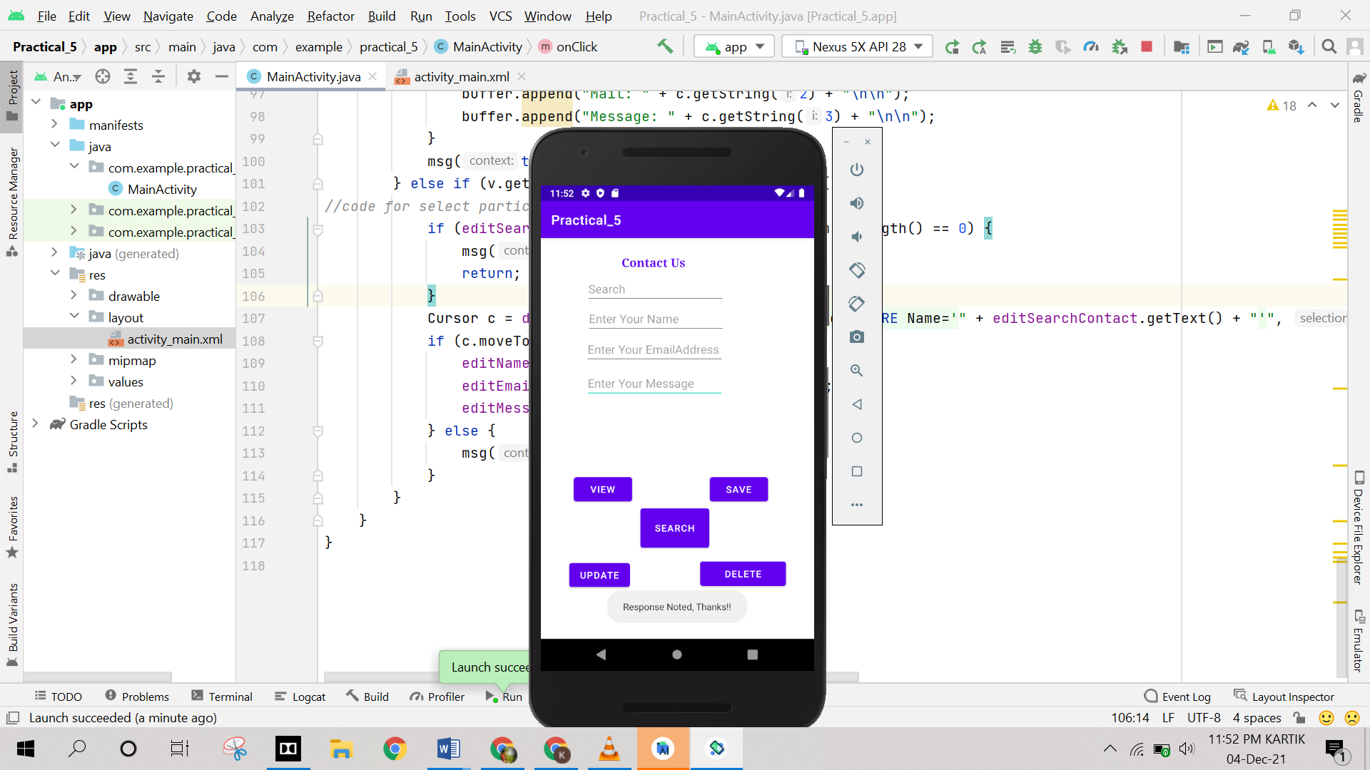

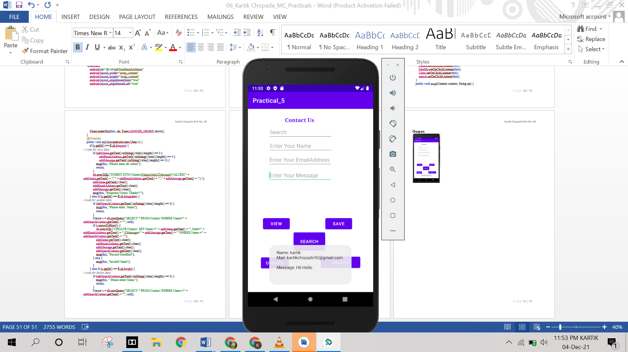

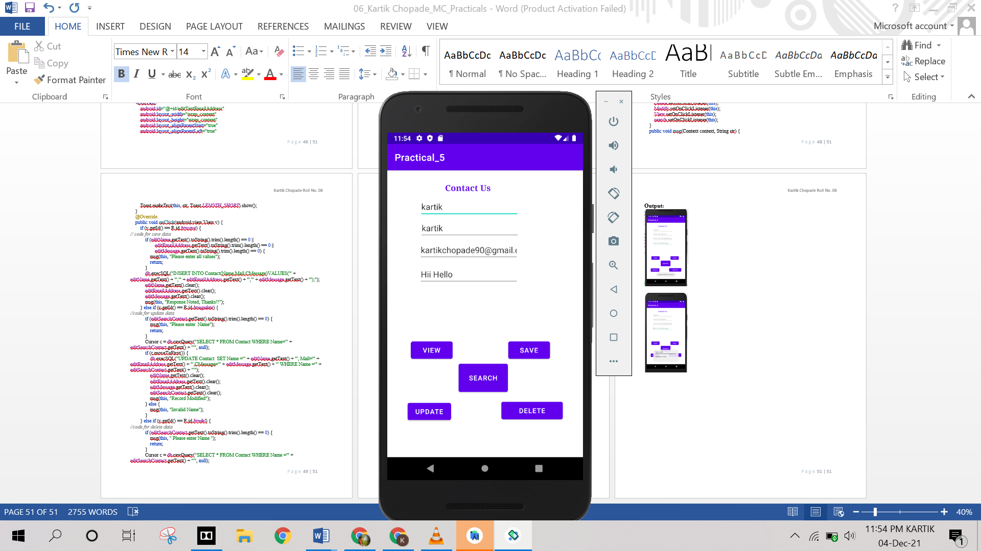

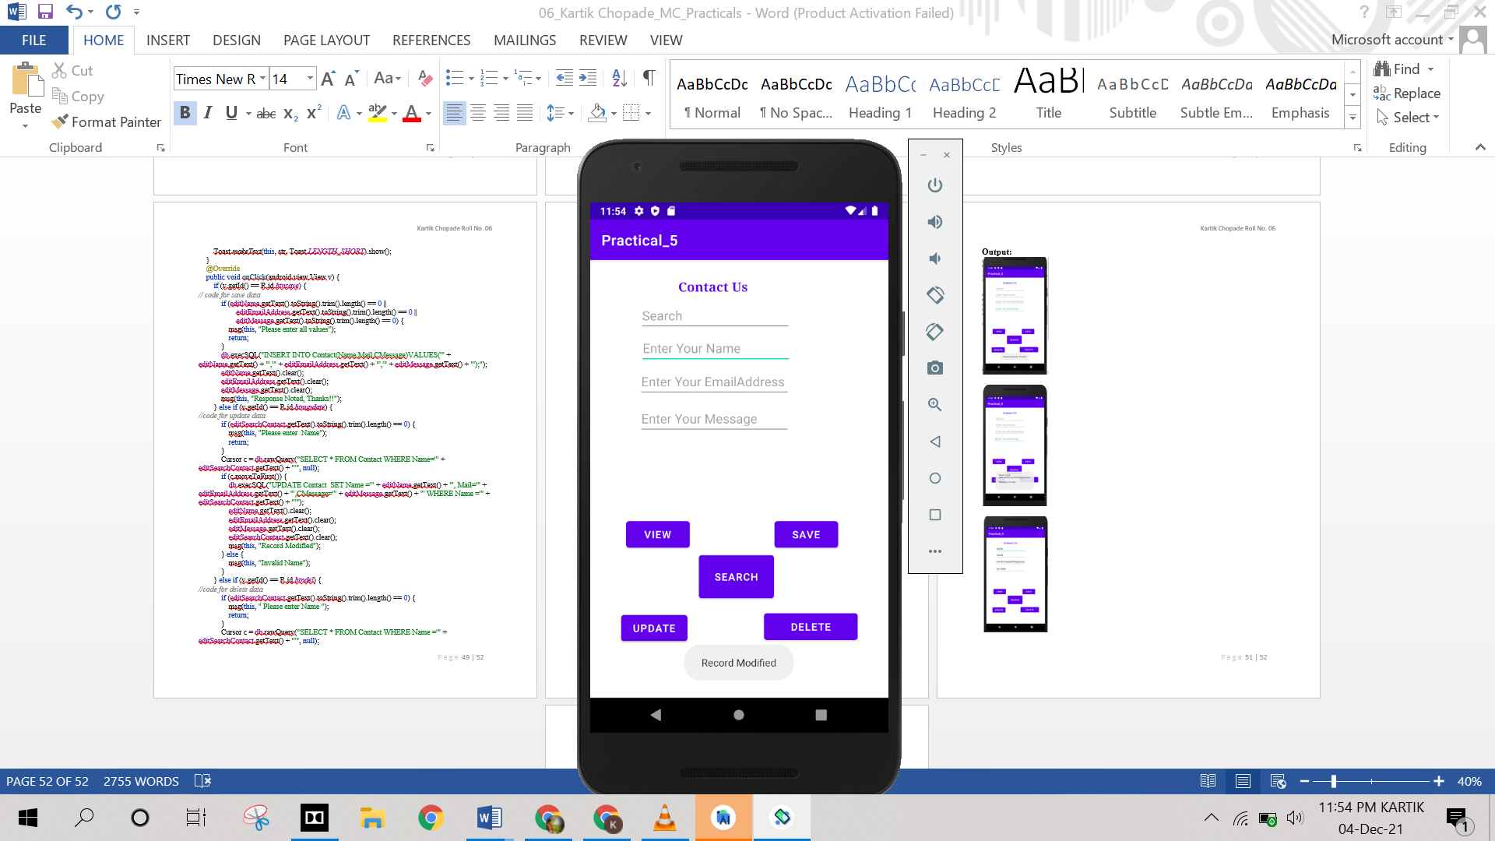

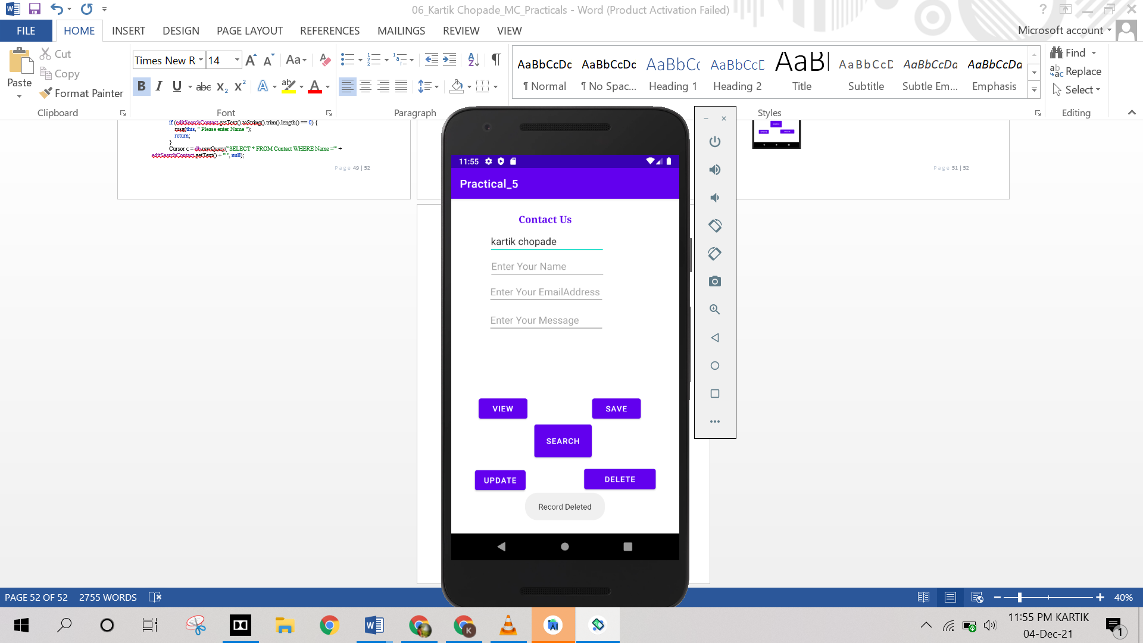

**Practical No. 14**

**Aim:** Create an application to do animation like rotate, move and fade the image.

**Program:**

**Activity_main.xml**

*<?*xml version="1.0" encoding="utf-8"*?>*<androidx.constraintlayout.widget.ConstraintLayout xmlns:android="http://schemas.android.com/apk/res/android"  
 xmlns:app="http://schemas.android.com/apk/res-auto"  
 xmlns:tools="http://schemas.android.com/tools"  
 android:layout_width="match_parent"  
 android:layout_height="match_parent"  
 tools:context=".MainActivity">  
 <TextView  
 android:id="@+id/tv1"  
 android:layout_width="335dp"  
 android:layout_height="55dp"  
 android:text="Animation on Image"  
 android:textSize="36sp"  
 app:layout_constraintBottom_toBottomOf="parent"  
 app:layout_constraintEnd_toEndOf="parent"  
 app:layout_constraintStart_toStartOf="parent"  
 app:layout_constraintTop_toTopOf="parent"  
 app:layout_constraintVertical_bias="0.059" />  
 <Button  
 android:id="@+id/b1"  
 android:layout_width="wrap_content"  
 android:layout_height="wrap_content"  
 android:onClick="move"  
 android:text="Move"  
 android:textSize="24sp"  
 app:layout_constraintBottom_toBottomOf="parent"  
 app:layout_constraintEnd_toEndOf="parent"  
 app:layout_constraintHorizontal_bias="0.117"  
 app:layout_constraintStart_toStartOf="parent"  
 app:layout_constraintTop_toTopOf="parent"  
 app:layout_constraintVertical_bias="0.177" />  
 <Button  
 android:id="@+id/b2"  
 android:layout_width="wrap_content"  
 android:layout_height="wrap_content"  
 android:onClick="fade"  
 android:text="Fade"  
 android:textSize="24sp"  
 app:layout_constraintBottom_toBottomOf="parent"  
 app:layout_constraintEnd_toEndOf="parent"  
 app:layout_constraintHorizontal_bias="0.117"  
 app:layout_constraintStart_toStartOf="parent"  
 app:layout_constraintTop_toTopOf="parent"  
 app:layout_constraintVertical_bias="0.177"  
 android:layout_marginLeft="130dp"/>  
 <Button  
 android:id="@+id/b3"  
 android:layout_width="wrap_content"  
 android:layout_height="wrap_content"  
 android:onClick="rotate"  
 android:text="Rotate"  
 android:textSize="24sp"  
 app:layout_constraintBottom_toBottomOf="parent"  
 app:layout_constraintEnd_toEndOf="parent"  
 app:layout_constraintHorizontal_bias="0.117"  
 app:layout_constraintStart_toStartOf="parent"  
 app:layout_constraintTop_toTopOf="parent"  
 app:layout_constraintVertical_bias="0.177"  
 android:layout_marginLeft="260dp"/>  
 <ImageView  
 android:id="@+id/imageView1"  
 android:layout_width="300dp"  
 android:layout_height="300dp"  
 app:layout_constraintBottom_toBottomOf="parent"  
 app:layout_constraintEnd_toEndOf="parent"  
 app:layout_constraintHorizontal_bias="0.495"  
 app:layout_constraintStart_toStartOf="parent"  
 app:layout_constraintTop_toTopOf="parent"  
 app:layout_constraintVertical_bias="0.642"  
 app:srcCompat="@drawable/image" />  
</androidx.constraintlayout.widget.ConstraintLayout>

**MainActivity.java**

package com.example.imagerotate;  
import androidx.appcompat.app.AppCompatActivity;  
import android.animation.AnimatorSet;  
import android.animation.ObjectAnimator;  
import android.os.Bundle;  
import android.view.View;  
import android.widget.ImageView;

public class MainActivity extends AppCompatActivity {  
 private ImageView img_view;  
 long animation_duration=1000;  
 @Override  
 protected void onCreate(Bundle savedInstanceState) {  
 super.onCreate(savedInstanceState);  
 setContentView(R.layout.*activity_main*);  
 img_view=(ImageView)findViewById(R.id.*imageView1*);  
 }  
 public void move(View view)  
 {  
 ObjectAnimator obj_ani_move = ObjectAnimator.*ofFloat*(img_view,"x",500f);  
 obj_ani_move.setDuration(animation_duration);  
 AnimatorSet ani_set = new AnimatorSet( );  
 ani_set.playTogether(obj_ani_move);  
 ani_set.start();  
 }  
 public void fade(View view)  
 {  
 ObjectAnimator obj_ani_fade = ObjectAnimator.*ofFloat*(img_view,View.*ALPHA*,1.0f,0.0f);  
 obj_ani_fade.setDuration(animation_duration);  
 AnimatorSet ani_set = new AnimatorSet( );  
 ani_set.playTogether(obj_ani_fade);  
 ani_set.start( );  
 }  
 public void rotate(View view)  
 {  
 ObjectAnimator obj_ani_rotate=ObjectAnimator.*ofFloat*(img_view,"rotation",0f,360f);  
 obj_ani_rotate.setDuration(animation_duration);  
 AnimatorSet ani_set=new AnimatorSet( );  
 ani_set.playTogether(obj_ani_rotate);  
 ani_set.start( );  
 }  
}

**Output:**

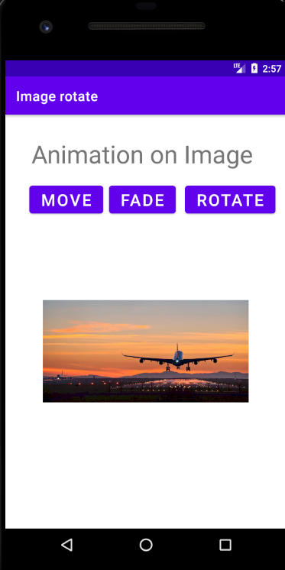

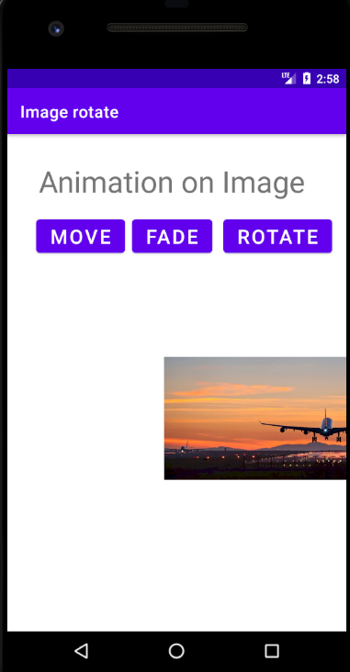

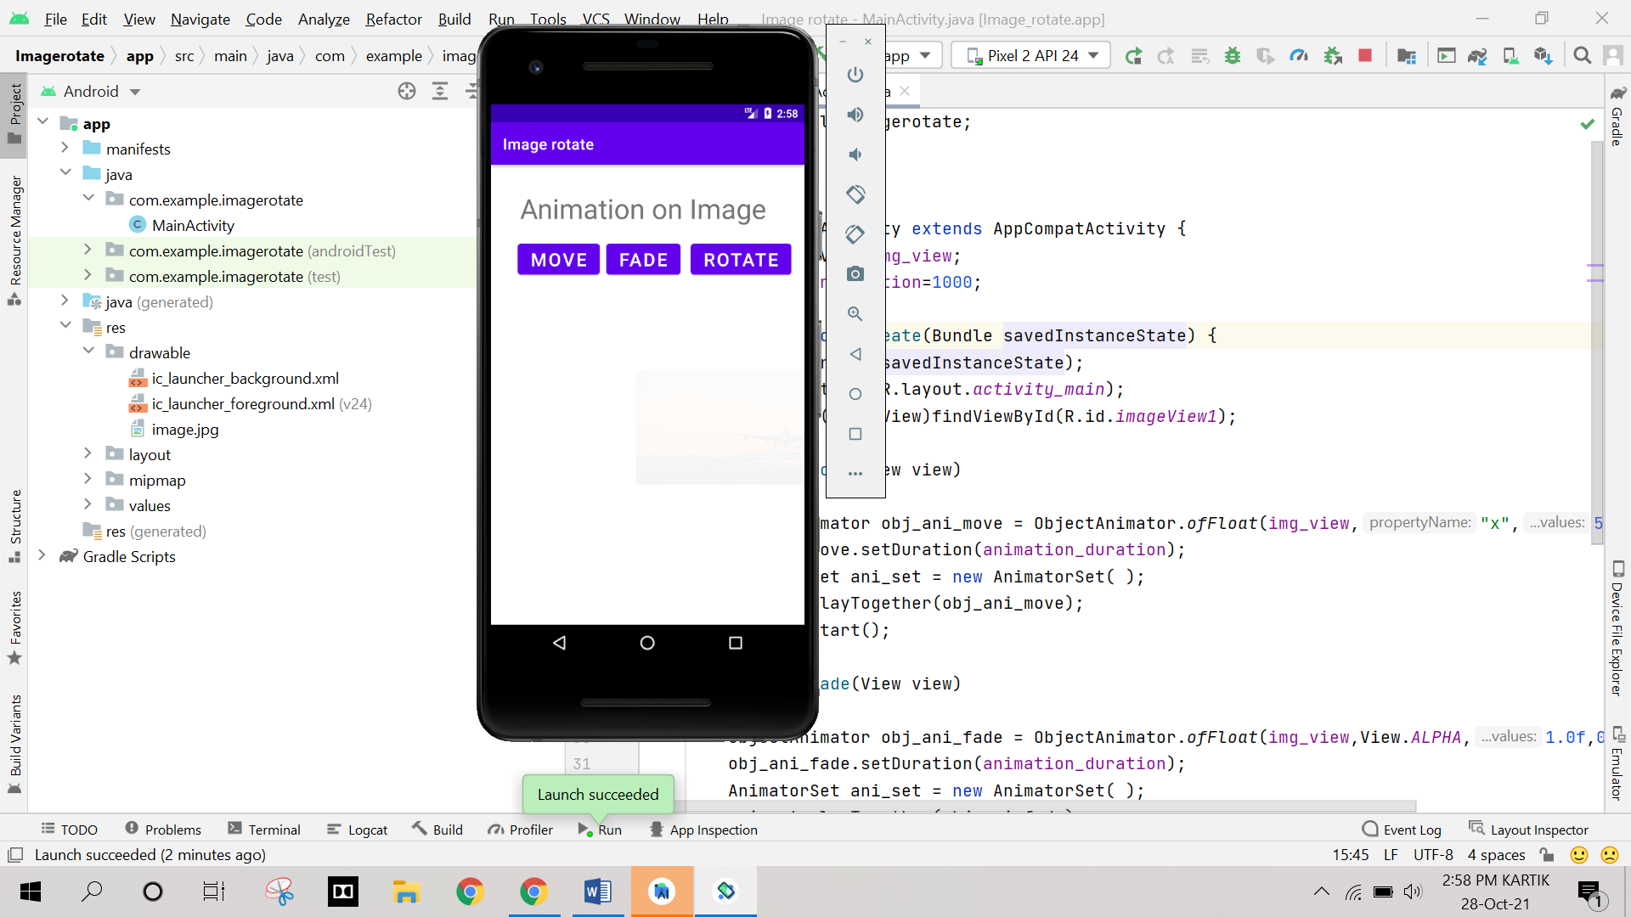

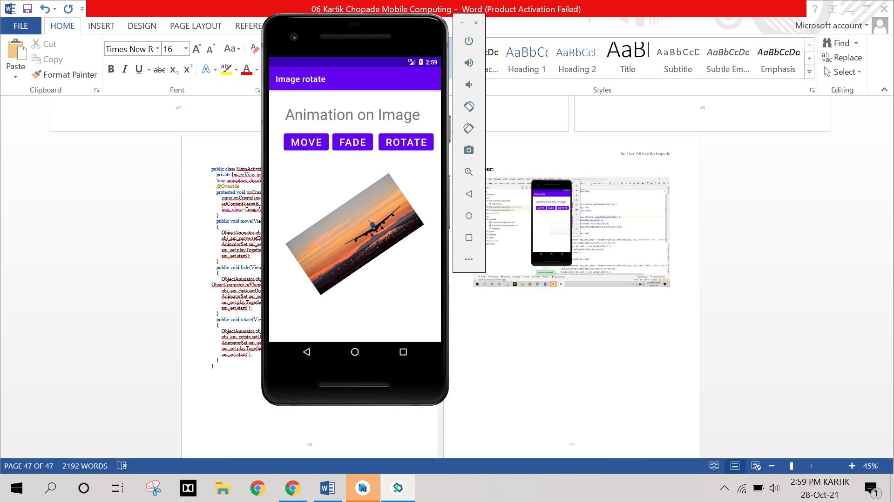

**Practical No. 15**

**Aim:** Create an application to demonstrate Shared preference.

**Program:**

**Activity_main.xml**

*<?*xml version="1.0" encoding="utf-8"*?>*<RelativeLayout xmlns:android="http://schemas.android.com/apk/res/android"  
 xmlns:app="http://schemas.android.com/apk/res-auto"  
 xmlns:tools="http://schemas.android.com/tools"  
 android:layout_width="match_parent"  
 android:layout_height="match_parent"  
 tools:context=".MainActivity">  
 <TextView  
 android:layout_width="wrap_content"  
 android:layout_height="wrap_content"  
 android:text="Login Form"  
 android:textSize="50sp"  
 android:layout_centerHorizontal="true"  
 android:layout_marginTop="20dp"/>  
 <TextView  
 android:id="@+id/textView"  
 android:layout_width="wrap_content"  
 android:layout_height="wrap_content"  
 android:text="Enter Email: "  
 android:textSize="30sp"  
 android:layout_marginTop="150dp"/>  
 <EditText  
 android:id="@+id/etEmail"  
 android:layout_width="match_parent"  
 android:layout_height="wrap_content"  
 android:layout_marginTop="150dp"  
 android:layout_marginStart="180dp"  
 android:inputType="textPersonName"/>  
 <TextView  
 android:id="@+id/textView2"  
 android:layout_width="wrap_content"  
 android:layout_height="wrap_content"  
 android:text="Enter Password: "  
 android:textSize="30sp"  
 android:layout_marginTop="240dp"/>  
 <EditText  
 android:id="@+id/etPassword"  
 android:layout_width="match_parent"  
 android:layout_height="wrap_content"  
 android:layout_marginTop="240dp"  
 android:layout_marginStart="220dp"/>  
 <CheckBox  
 android:id="@+id/Chkrem"  
 android:layout_width="wrap_content"  
 android:layout_height="wrap_content"  
 android:text="Remember me"  
 android:textSize="30sp"  
 android:layout_marginTop="320dp"  
 android:layout_centerHorizontal="true"/>  
 <Button  
 android:id="@+id/btnSave"  
 android:layout_width="wrap_content"  
 android:layout_height="wrap_content"  
 android:text="Save"  
 android:textSize="40sp"  
 android:onClick="Save"  
 android:layout_marginTop="400dp"  
 android:layout_marginStart="10dp"/>  
 <Button  
 android:id="@+id/btnClear"  
 android:onClick="Clear"  
 android:layout_width="wrap_content"  
 android:layout_height="wrap_content"  
 android:text="Clear"  
 android:textSize="40sp"  
 android:layout_marginTop="400dp"  
 android:layout_marginStart="220dp"/>  
  
</RelativeLayout>

MainActivity.java

package com.example.practical6;  
  
import androidx.appcompat.app.AppCompatActivity;  
import android.content.Context;  
import android.content.SharedPreferences;  
import android.os.Bundle;  
import android.view.View;  
import android.widget.CheckBox;  
import android.widget.TextView;  
import android.widget.Toast;  
  
public class MainActivity extends AppCompatActivity {  
 SharedPreferences sharedpreferences;  
 TextView email;  
 TextView password;  
 CheckBox remember;  
 public static final String *mypreference*="mypref";  
 public static final String *Password*="passwordKey";  
 public static final String *Email*="emailKey";  
 @Override  
 protected void onCreate(Bundle savedInstanceState) {  
 super.onCreate(savedInstanceState);  
 setContentView(R.layout.*activity_main*);  
 email=(TextView)findViewById(R.id.*etEmail*);  
 password=(TextView)findViewById(R.id.*etPassword*);  
 remember=(CheckBox)findViewById(R.id.*Chkrem*);  
 sharedpreferences=getSharedPreferences(*mypreference*, Context.*MODE_PRIVATE*);  
 if(sharedpreferences.contains(*Email*));  
 {  
 email.setText(sharedpreferences.getString(*Email*,""));  
 }  
 if(sharedpreferences.contains(*Password*))  
 {  
 password.setText(sharedpreferences.getString(*Password*,""));  
 }  
 }  
 public void Save(View view)  
 {  
 if(remember.isChecked()) {  
 String e = email.getText().toString();  
 String p = password.getText().toString();  
 SharedPreferences.Editor editor = sharedpreferences.edit();  
 editor.putString(*Email*, e);  
 editor.putString(*Password*, p);  
 editor.commit();  
 Toast toast = Toast.*makeText*(getApplicationContext(),"value stored in shared preference",  
 Toast.*LENGTH_SHORT*);  
 toast.show();  
 }  
 }  
 public void Clear(View view)  
 {  
 email=(TextView)findViewById(R.id.*etEmail*);  
 password=(TextView)findViewById(R.id.*etPassword*);  
 email.setText(" ");  
 password.setText(" ");  
 }  
}

**Output:**

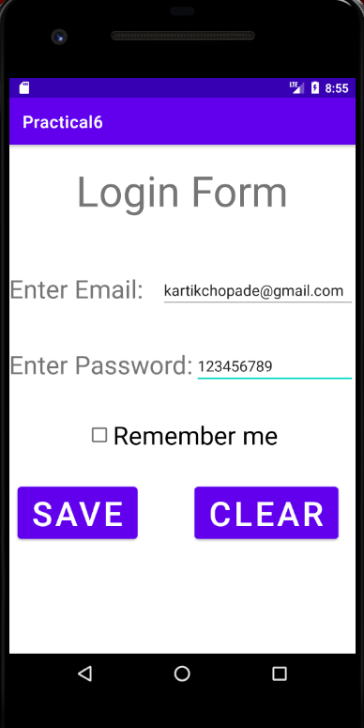

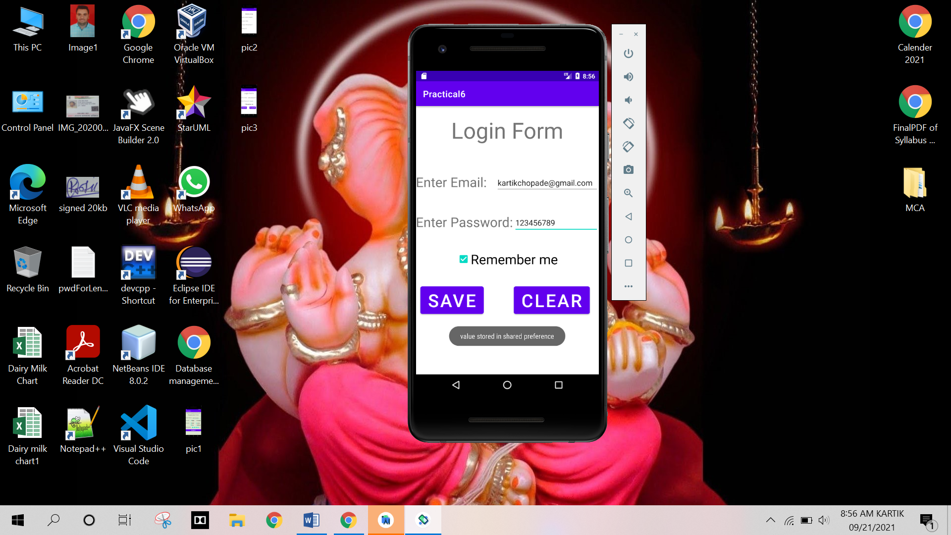

**Practical No. 16**

**Aim:** Write an application to download an image using httpurlconnection.

**Program:**

**AndroidManifiest.xml**

*<?*xml version="1.0" encoding="utf-8"*?>*<manifest xmlns:android="http://schemas.android.com/apk/res/android"  
 package="com.example.downloadimage">  
 <uses-permission android:name="android.permission.INTERNET"></uses-permission>  
 <uses-permission android:name="android.permission.ACCESS_NETWORK_STATE"></uses-permission>  
 <uses-permission android:name="android.permission.READ_PHONE_STATE"></uses-permission>  
 <application  
 android:allowBackup="true"  
 android:icon="@mipmap/ic_launcher"  
 android:label="@string/app_name"  
 android:roundIcon="@mipmap/ic_launcher_round"  
 android:supportsRtl="true"  
 android:theme="@style/Theme.DownloadImage">  
 <activity  
 android:name=".MainActivity"  
 android:exported="true">  
 <intent-filter>  
 <action android:name="android.intent.action.MAIN" />  
  
 <category android:name="android.intent.category.LAUNCHER" />  
 </intent-filter>  
 </activity>  
 </application>  
  
</manifest>

**Activity_main.xml**

*<?*xml version="1.0" encoding="utf-8"*?>*<RelativeLayout xmlns:android="http://schemas.android.com/apk/res/android"  
 xmlns:app="http://schemas.android.com/apk/res-auto"  
 xmlns:tools="http://schemas.android.com/tools"  
 android:layout_width="match_parent"  
 android:layout_height="match_parent"  
 tools:context=".MainActivity">  
 <TextView  
 android:layout_width="wrap_content"  
 android:layout_height="wrap_content"  
 android:id="@+id/textView"  
 android:text="Web Page Image"  
 android:layout_alignParentTop="true"  
 android:layout_centerHorizontal="true"  
 android:layout_marginTop="29dp"  
 android:textSize="25sp" />  
 <ImageView  
 android:layout_width="wrap_content"  
 android:layout_height="wrap_content"  
 android:id="@+id/imageView"  
 android:layout_below="@+id/textView"  
 android:layout_centerHorizontal="true" />  
 <Button  
 android:id="@+id/button"  
 android:layout_width="wrap_content"  
 android:layout_height="wrap_content"  
 android:layout_centerInParent="true"  
 android:text="Download"  
 android:textAppearance="@style/TextAppearance.AppCompat.Display1" />  
</RelativeLayout>

**MainActivity.java**

package com.example.downloadimage;  
  
import androidx.appcompat.app.AppCompatActivity;  
import android.app.ProgressDialog;  
import android.graphics.Bitmap;  
import android.graphics.BitmapFactory;  
import android.net.ConnectivityManager;  
import android.os.Bundle;  
import android.os.Handler;  
import android.os.Message;  
import android.view.View;  
import android.widget.Button;  
import android.widget.ImageView;  
import android.widget.Toast;  
  
import java.io.IOException;  
import java.io.InputStream;  
import java.net.HttpURLConnection;  
import java.net.MalformedURLException;  
import java.net.URL;  
import java.net.URLConnection;  
  
public class MainActivity extends AppCompatActivity {  
 private ProgressDialog progressDialog;  
 private Bitmap bitmap = null;  
 Button b1;  
  
 @Override  
 protected void onCreate(Bundle savedInstanceState) {  
 super.onCreate(savedInstanceState);  
 setContentView(R.layout.*activity_main*);  
 b1 = (Button)findViewById(R.id.*button*);  
 b1.setOnClickListener(new View.OnClickListener() {  
 @Override  
 public void onClick(View v) {  
 checkInternetConenction();  
 downloadImage("https://cdn.pixabay.com/photo/2015/04/19/08/32/marguerite-729510__480.jpg");  
 }  
 });  
 }  
 private void downloadImage(String urlStr) {  
 progressDialog = ProgressDialog.*show*(this, "", "Downloading Image from " + urlStr);  
 final String url = urlStr;  
 new Thread() {  
 public void run() {  
 InputStream in = null;  
 Message msg = Message.*obtain*();  
 msg.what = 1;  
 try {  
 in = openHttpConnection(url);  
 bitmap = BitmapFactory.*decodeStream*(in);  
 Bundle b = new Bundle();  
 b.putParcelable("bitmap", bitmap);  
 msg.setData(b);  
 in.close();  
 }catch (IOException e1) {  
 e1.printStackTrace();  
 }  
 messageHandler.sendMessage(msg);  
 }  
 }.start();  
 }  
 private InputStream openHttpConnection(String urlStr) {  
 InputStream in = null;  
 int resCode = -1;  
 try {  
 URL url = new URL(urlStr);  
 URLConnection urlConn = url.openConnection();  
 if (!(urlConn instanceof HttpURLConnection)) {  
 throw new IOException("URL is not an Http URL");  
 }  
 HttpURLConnection httpConn = (HttpURLConnection) urlConn;  
 httpConn.setAllowUserInteraction(false);  
 httpConn.setInstanceFollowRedirects(true);  
 httpConn.setRequestMethod("GET");  
 httpConn.connect();  
 resCode = httpConn.getResponseCode();  
 if (resCode == HttpURLConnection.*HTTP_OK*) {  
 in = httpConn.getInputStream();  
 }  
 }catch (MalformedURLException e) {  
 e.printStackTrace();  
 }catch (IOException e) {  
 e.printStackTrace();}  
 return in;  
 }  
 private Handler messageHandler = new Handler() {  
 public void handleMessage(Message msg) {  
 super.handleMessage(msg);  
 ImageView img=(ImageView)findViewById(R.id.*imageView*);  
 img.setImageBitmap((Bitmap) (msg.getData().getParcelable("bitmap")));  
 progressDialog.dismiss();  
 }  
 };  
 private boolean checkInternetConenction() {  
*// get Connectivity Manager object to check connection* ConnectivityManager connec =(ConnectivityManager)getSystemService(getBaseContext().*CONNECTIVITY_SERVICE*);  
 if ( connec.getNetworkInfo(0).getState() ==  
 android.net.NetworkInfo.State.*CONNECTED* ||  
 connec.getNetworkInfo(0).getState() ==  
 android.net.NetworkInfo.State.*CONNECTING* ||  
 connec.getNetworkInfo(1).getState() ==  
 android.net.NetworkInfo.State.*CONNECTING* ||  
 connec.getNetworkInfo(1).getState() == android.net.NetworkInfo.State.*CONNECTED* ) {  
 Toast.*makeText*(this, "Connected", Toast.*LENGTH_LONG*).show();  
 return true;  
 }else if (  
 connec.getNetworkInfo(0).getState() ==  
 android.net.NetworkInfo.State.*DISCONNECTED* ||  
 connec.getNetworkInfo(1).getState() ==  
 android.net.NetworkInfo.State.*DISCONNECTED* ) {  
 Toast.*makeText*(this,"Not Connected", Toast.*LENGTH_LONG*).show();  
 return false;  
 }  
 return false;  
 }  
}

**Output:**

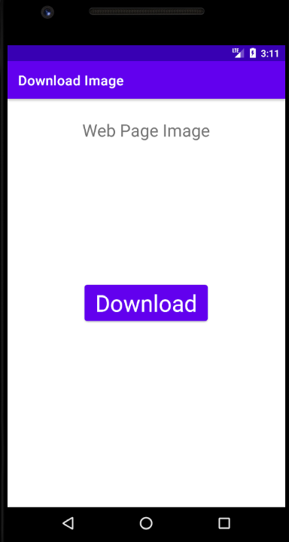

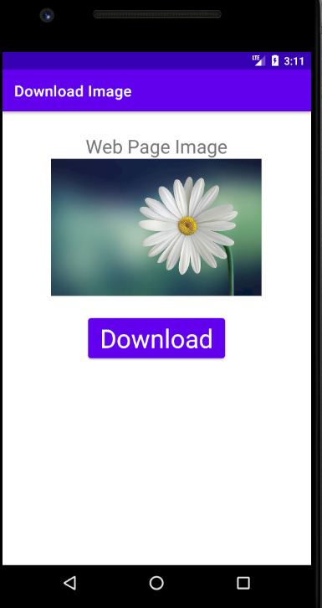

**Practical No. 17**

**Aim:** Create an application to play video.

**First Create new Android Resource Directory (raw) in Resource root**

**Activity_main.xml**

*<?*xml version="1.0" encoding="utf-8"*?>*<RelativeLayout xmlns:android="http://schemas.android.com/apk/res/android"  
 xmlns:app="http://schemas.android.com/apk/res-auto"  
 xmlns:tools="http://schemas.android.com/tools"  
 android:layout_width="match_parent"  
 android:layout_height="match_parent"  
 tools:context=".MainActivity">  
 <VideoView  
 android:id="@+id/videoview1"  
 android:layout_width="match_parent"  
 android:layout_height="wrap_content"  
 android:layout_centerHorizontal="true" />  
</RelativeLayout>

**MainActivity.java**

package com.example.video;  
  
import androidx.appcompat.app.AppCompatActivity;  
import android.os.Bundle;  
import android.widget.MediaController;  
import android.widget.VideoView;  
  
public class MainActivity extends AppCompatActivity {  
 VideoView videoid;  
 MediaController mediaController;  
 @Override  
 protected void onCreate(Bundle savedInstanceState) {  
 super.onCreate(savedInstanceState);  
 setContentView(R.layout.*activity_main*);  
 videoid=(VideoView) findViewById(R.id.*videoview1*);  
 mediaController=new MediaController(this);  
 videoid.setVideoPath("android.resource://"+getPackageName()+"/"+R.raw.*video*);  
 mediaController.setAnchorView(videoid);  
 videoid.setMediaController(mediaController);  
 videoid.start();  
 }  
}

**Output:**

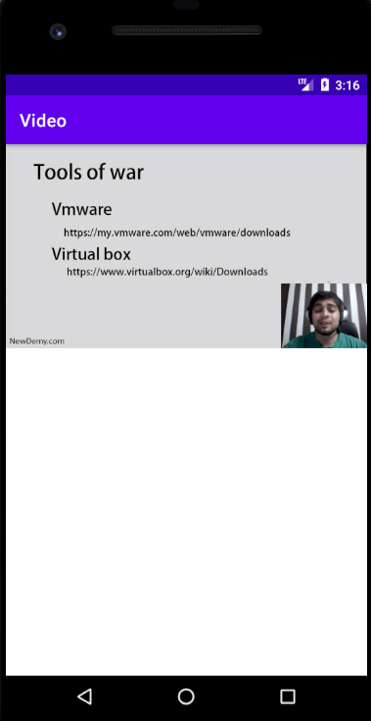

**Practical No. 18**

**Aim:** Write an application to display latitude and longitude of the current location.

**Program:**

**AndroidManifiest.xml**

*<?*xml version="1.0" encoding="utf-8"*?>*<manifest xmlns:android="http://schemas.android.com/apk/res/android"  
 xmlns:tools="http://schemas.android.com/tools"  
 package="com.example.location">  
 <uses-permission android:name="android.permission.ACCESS_FINE_LOCATION"></uses-permission>  
 <uses-permission android:name="android.permission.ACCESS_COARSE_LOCATION"></uses-permission>  
 <application  
 android:allowBackup="true"  
 android:icon="@mipmap/ic_launcher"  
 android:label="@string/app_name"  
 android:roundIcon="@mipmap/ic_launcher_round"  
 android:supportsRtl="true"  
 android:theme="@style/Theme.Location">  
 <activity  
 android:name=".MainActivity"  
 android:exported="true">  
 <intent-filter>  
 <action android:name="android.intent.action.MAIN" />  
 <category android:name="android.intent.category.LAUNCHER" />  
 </intent-filter>  
 </activity>  
 </application>  
</manifest>

**Activity_main.xml**

*<?*xml version="1.0" encoding="utf-8"*?>*<RelativeLayout xmlns:android="http://schemas.android.com/apk/res/android"  
 xmlns:app="http://schemas.android.com/apk/res-auto"  
 xmlns:tools="http://schemas.android.com/tools"  
 android:layout_width="match_parent"  
 android:layout_height="match_parent"  
 tools:context=".MainActivity">  
 <TextView  
 android:id="@+id/location"  
 android:layout_width="wrap_content"  
 android:layout_height="wrap_content"  
 android:layout_alignParentTop="true"  
 android:layout_centerHorizontal="true"  
 android:layout_marginTop="90dp"  
 android:text="Location"/>  
 <Button  
 android:id="@+id/btn"  
 android:layout_width="wrap_content"  
 android:layout_height="wrap_content"  
 android:layout_alignParentStart="true"  
 android:layout_alignParentTop="true"  
 android:layout_marginStart="119dp"  
 android:layout_marginTop="210dp"  
 android:text="Get Location"  
 android:layout_alignParentLeft="true"  
 android:layout_marginLeft="119dp">  
 </Button>  
</RelativeLayout>

**MainActivity.java**

package com.example.location;  
import static android.Manifest.permission.*ACCESS_COARSE_LOCATION*;  
import static android.Manifest.permission.*ACCESS_FINE_LOCATION*;  
import androidx.appcompat.app.AppCompatActivity;  
import androidx.core.app.ActivityCompat;  
import android.content.pm.PackageManager;  
import android.location.Location;  
import android.os.Bundle;  
import android.view.View;  
import android.widget.Button;  
import android.widget.TextView;  
import com.google.android.gms.location.FusedLocationProviderClient;  
import com.google.android.gms.location.LocationServices;  
import com.google.android.gms.tasks.OnSuccessListener;  
public class MainActivity extends AppCompatActivity {  
 private FusedLocationProviderClient cl;  
 @Override  
 protected void onCreate(Bundle savedInstanceState) {  
 super.onCreate(savedInstanceState);  
 setContentView(R.layout.*activity_main*);  
 requestPermission();  
 cl = LocationServices.*getFusedLocationProviderClient*(this);  
 Button btn1 = (Button) findViewById(R.id.*btn*);  
 btn1.setOnClickListener(new View.OnClickListener() {  
 public void onClick(View v) {  
 if (ActivityCompat.*checkSelfPermission*(MainActivity.this, *ACCESS_FINE_LOCATION*) != PackageManager.*PERMISSION_GRANTED*) {  
 return;  
 }  
 cl.getLastLocation().addOnSuccessListener(MainActivity.this, new OnSuccessListener<Location>() {  
 @Override  
 public void onSuccess(Location location) {  
 if (location != null) {  
 TextView tv = (TextView) findViewById(R.id.*location*);  
 tv.setText(location.toString());  
 }  
 }  
 });  
 }  
 });  
 }  
 private void requestPermission() {  
 ActivityCompat.*requestPermissions*(this, new String[]{*ACCESS_FINE_LOCATION*}, 1);  
 ActivityCompat.*requestPermissions*(this, new String[]{*ACCESS_COARSE_LOCATION*}, 1);  
 }  
}

**Output:**

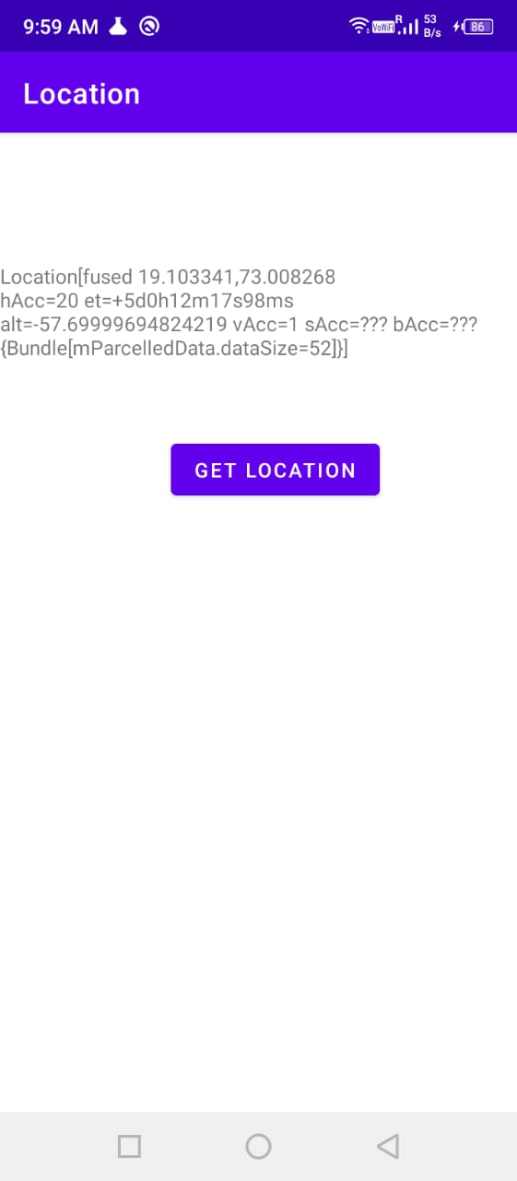

**Practical No. 19**

**Aim:** Create an application to demonstrate volley JSON.

**Program:**

**AndroidManifiest.xml**

*<?*xml version="1.0" encoding="utf-8"*?>*<manifest xmlns:android="http://schemas.android.com/apk/res/android"  
 package="com.example.json_async" >  
 <uses-permission android:name="android.permission.INTERNET"></uses-permission>  
 <uses-permission android:name="android.permission.ACCESS_WIFI_STATE"></uses-permission>  
 <application  
 android:allowBackup="true"  
 android:icon="@mipmap/ic_launcher"  
 android:label="@string/app_name"  
 android:roundIcon="@mipmap/ic_launcher_round"  
 android:supportsRtl="true"  
 android:theme="@style/Theme.Json_Async" >  
 <activity  
 android:name=".MainActivity"  
 android:exported="true" >  
 <intent-filter>  
 <action android:name="android.intent.action.MAIN" />  
  
 <category android:name="android.intent.category.LAUNCHER" />  
 </intent-filter>  
 </activity>  
 </application>  
  
</manifest>

**Activity_main.xml**

*<?*xml version="1.0" encoding="utf-8"*?>*<RelativeLayout xmlns:android="http://schemas.android.com/apk/res/android"  
 xmlns:tools="http://schemas.android.com/tools"  
 xmlns:app="http://schemas.android.com/apk/res-auto"  
 android:layout_width="match_parent"  
 android:layout_height="match_parent"  
 tools:context=".MainActivity">  
 <Button  
 android:layout_width="wrap_content"  
 android:layout_height="wrap_content"  
 android:text="Click"  
 android:layout_marginBottom="10dp"  
 android:id="@+id/button"/>  
 <ScrollView  
 android:layout_width="match_parent"  
 android:layout_height="match_parent"  
 android:layout_below="@id/button">  
 <TextView  
 android:layout_width="match_parent"  
 android:layout_height="match_parent"  
 android:layout_below="@id/button"  
 android:padding="5dp"  
 android:hint="Fetching"  
 android:textSize="25sp"  
 android:id="@+id/fetcheddata"/>  
 </ScrollView>  
</RelativeLayout>

**MainActivity.java**

package com.example.json_async;  
import androidx.appcompat.app.AppCompatActivity;  
import android.os.Bundle;  
import android.view.View;  
import android.widget.Button;  
import android.widget.TextView;  
public class MainActivity extends AppCompatActivity {  
 Button click;  
 public static TextView *data*;  
 @Override  
 protected void onCreate(Bundle savedInstanceState) {  
 super.onCreate(savedInstanceState);  
 setContentView(R.layout.*activity_main*);  
 click = (Button) findViewById(R.id.*button*);  
 *data* = (TextView) findViewById(R.id.*fetcheddata*);  
 click.setOnClickListener(new View.OnClickListener() {  
 @Override  
 public void onClick(View view) {  
 fetchedDta process = new fetchedDta();  
 process.execute();  
 }  
 });  
 }  
}

**fetchDta.java**

package com.example.json_async;  
import android.os.AsyncTask;  
import org.json.JSONArray;  
import org.json.JSONException;  
import org.json.JSONObject;  
import java.io.BufferedReader;  
import java.io.IOException;  
import java.io.InputStream;  
import java.io.InputStreamReader;  
import java.net.HttpURLConnection;  
import java.net.MalformedURLException;  
import java.net.URL;  
public class fetchedDta extends AsyncTask<Void,Void,Void> {  
 String data ="";  
 String dataParsed = "";  
 String singleParsed ="";  
 @Override  
 protected Void doInBackground(Void... voids) {  
 try {  
 URL url = new URL("http://myjson.dit.upm.es/api/bins/766r");  
 HttpURLConnection httpURLConnection = (HttpURLConnection) url.openConnection();  
 InputStream inputStream = httpURLConnection.getInputStream();  
 BufferedReader bufferedReader = new BufferedReader(new InputStreamReader(inputStream));  
 String line = "";  
 while(line != null){  
 line = bufferedReader.readLine();  
 data = data + line;  
 }  
 JSONArray JA = new JSONArray(data);  
 for(int i =0 ;i < JA.length(); i++){  
 JSONObject JO = (JSONObject) JA.get(i);  
 singleParsed = "Name:" + JO.get("name") + "\n"+  
 "Age:" + JO.get("age") + "\n"+  
 "City:" + JO.get("city") + "\n"+  
 "Country:" + JO.get("country") + "\n";  
 dataParsed = dataParsed + singleParsed +"\n" ;  
 }  
 } catch (MalformedURLException e) {  
 e.printStackTrace();  
 } catch (IOException e) {  
 e.printStackTrace();  
 } catch (JSONException e) {  
 e.printStackTrace();  
 }  
 return null;  
 }  
 @Override  
 protected void onPostExecute(Void unused) {  
 super.onPostExecute(unused);  
 MainActivity.*data*.setText(this.dataParsed);  
 }  
}

**Output:**

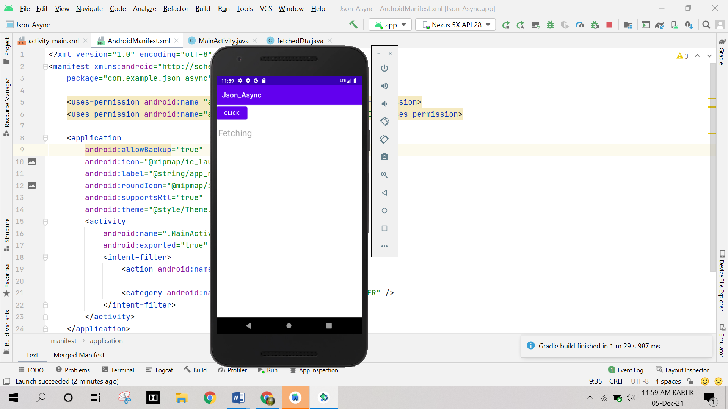

**Practical No. 20**

**Aim:** write a program in dart to demonstrate variables and arrays.

**Program:**

void main() {

var fname = "Kartik";

var lname = "chopade";

var fruits = ['Mango', 'Apple', 'Banana'];

var assoArray = {

'friend': 'Suraj',

'url': 'https://dart.dev/get-dart/archive'

};

print('Hello World');

print(fname + '' + lname);

print(fruits);

print(fruits[0]);

print(assoArray);

print(assoArray['friend']);

for (var fruit in fruits) {

print(fruit);

}

for (int i = 1; i <= 10; i++) {

print(i);

}

}

**Output:**

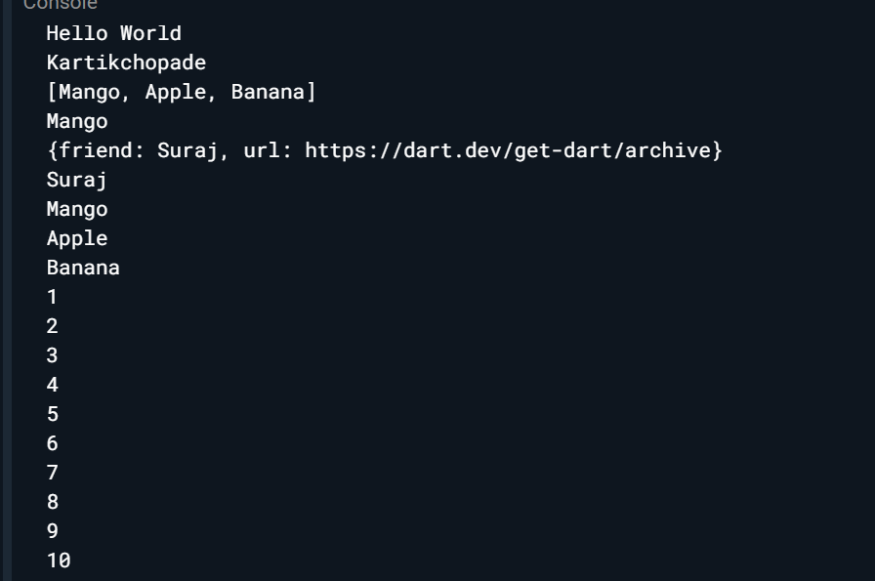

**Practical No. 21**

**Aim:** Write a program in dart to find square of a number using function.

**Program:**

void main() {

int number;

int square(int number) {

int result = number * number;

return result;

}

print(square(8));

}

**Output:**

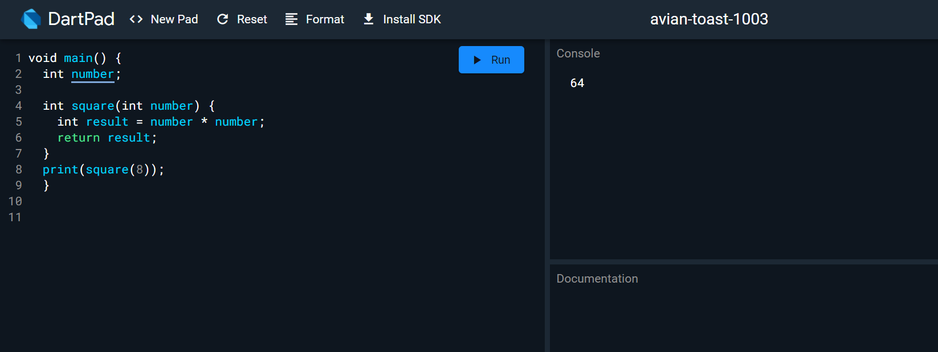

**Practical No. 22**

**Aim:** write a program in dart to demonstrate class andconstructor of a class.

**Program:**

class Student

{

String name;

int age=0;

Student(this.name,this.age);

Student.constructor1(this.name);

Student.constructor2(this.name,this.age);

String get stud_name

{

return name;

}

void set stud_name(String name)

{

this.name=name;

}

void set stud_age(int age)

{

if(age<=0)

{

print("Age should be greate than 5");

}

else

{

this.age=age;

}

}

int get stud_age

{

return age;

}

}

void main()

{

Student s1= new Student("kartik",23);

Student s2=new Student.constructor1("chopade");

Student s3=new Student.constructor2("Mumbai",23);

print(s1.stud_name);

print(s1.stud_age);

print(s2.stud_name);

print(s3.stud_name);

print(s3.stud_age);

}

**Output:**

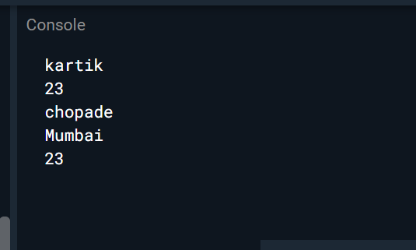

**Practical No. 23**

**Aim:** create a simple app in flutter to display hello world.

**Program:**

**Main.dart**

import 'package:flutter/material.dart';  
void main() {  
 runApp(const MyApp());  
}  
class MyApp extends StatelessWidget {  
 const MyApp({Key? key}) : super(key: key);  
 *// This widget is the root of your application.  
 //@override* Widget build(BuildContext context) {  
 return Directionality(  
 textDirection: TextDirection.ltr,  
 child: Center(  
 child: Text("Hello Flutter")  
 )  
 );  
 }  
}

**Output:**

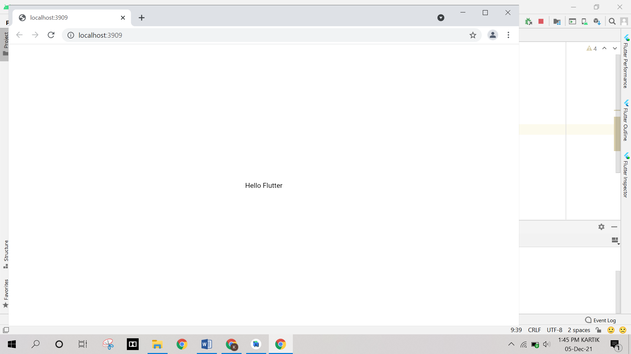

**Practical No. 24**

**Aim:** write a code in flutter to demonstrate metarial design and display message.

**Program:**

**Main.dart**

import 'package:flutter/material.dart';  
void main() {  
 runApp(  
 const MaterialApp(  
 title: 'Flutter Tutorial',  
 home: TutorialHome(),  
 ),  
 );  
}  
class TutorialHome extends StatelessWidget {  
 const TutorialHome({Key? key}) : super(key: key);  
 @override  
 Widget build(BuildContext context) {  
*// Scaffold is a layout for  
// the major Material Components.* return Scaffold(  
 appBar: AppBar(  
 leading: const IconButton(  
 icon: Icon(Icons.*menu*),  
 tooltip: 'Navigation menu',  
 onPressed: null,  
 ),  
 title: const Text('Example title'),  
 actions: const [  
 IconButton(  
 icon: Icon(Icons.*search*),  
 tooltip: 'Search',  
 onPressed: null,  
 ),  
 ],  
 ),  
*// body is the majority of the screen.* body: const Center(  
 child: Text('Hello, world!'),  
 ),  
 floatingActionButton: const FloatingActionButton(  
 tooltip: 'Add', *// used by assistive technologies* child: Icon(Icons.*add*),  
 onPressed: null,  
 ),  
 );  
 }  
}

**Output:**

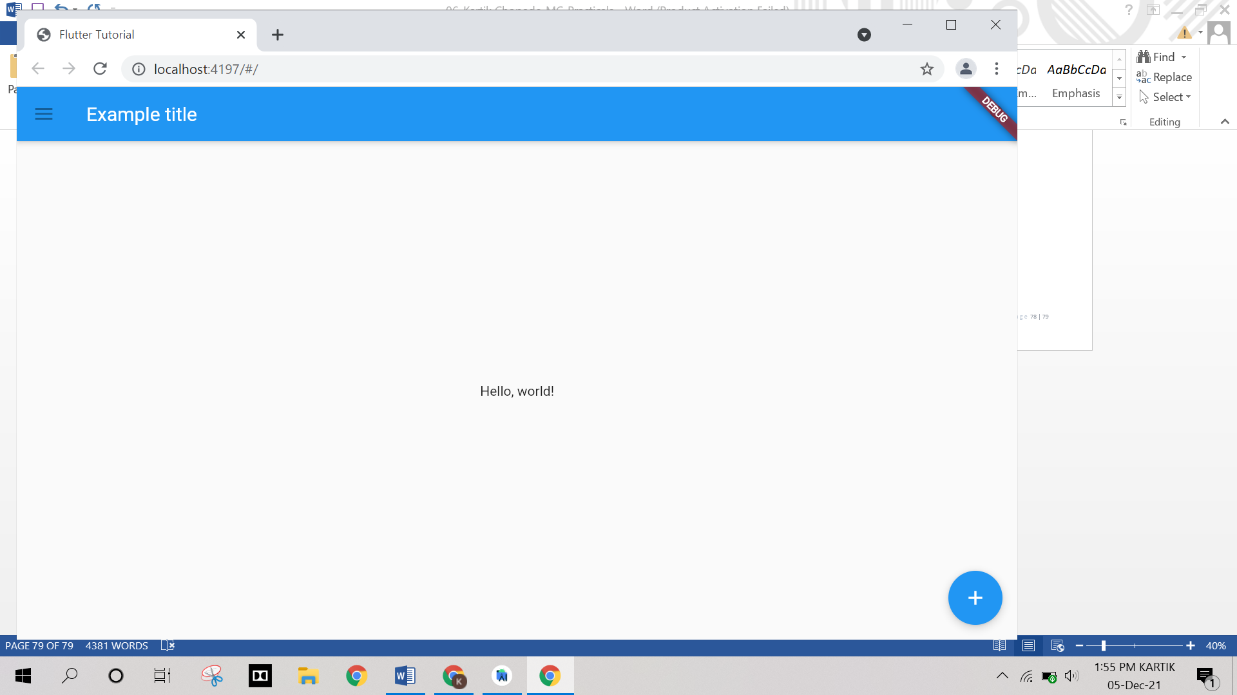

**Practical No. 25**

**Aim:** create a simple app in flutter to demonstrate row/column display.

**Program:**

**Main.dart**

import 'package:flutter/material.dart';  
void main() {  
 runApp(MyApp());  
}  
class MyApp extends StatelessWidget {  
 Widget build(BuildContext contex)  
 {  
 return MaterialApp(  
 title: "Demo2-Material Design",  
 home: Scaffold(  
 appBar: AppBar(  
 title: Text("Demo2-Material Design"),  
 ),  
 body: Center(  
 child:Row(  
 mainAxisAlignment: MainAxisAlignment.center,  
 children: <Widget>[  
 Text('Child1'),  
 Text('Child2'),  
 ],  
 )  
 ),  
 ),  
 );  
 }  
}

**Output:**

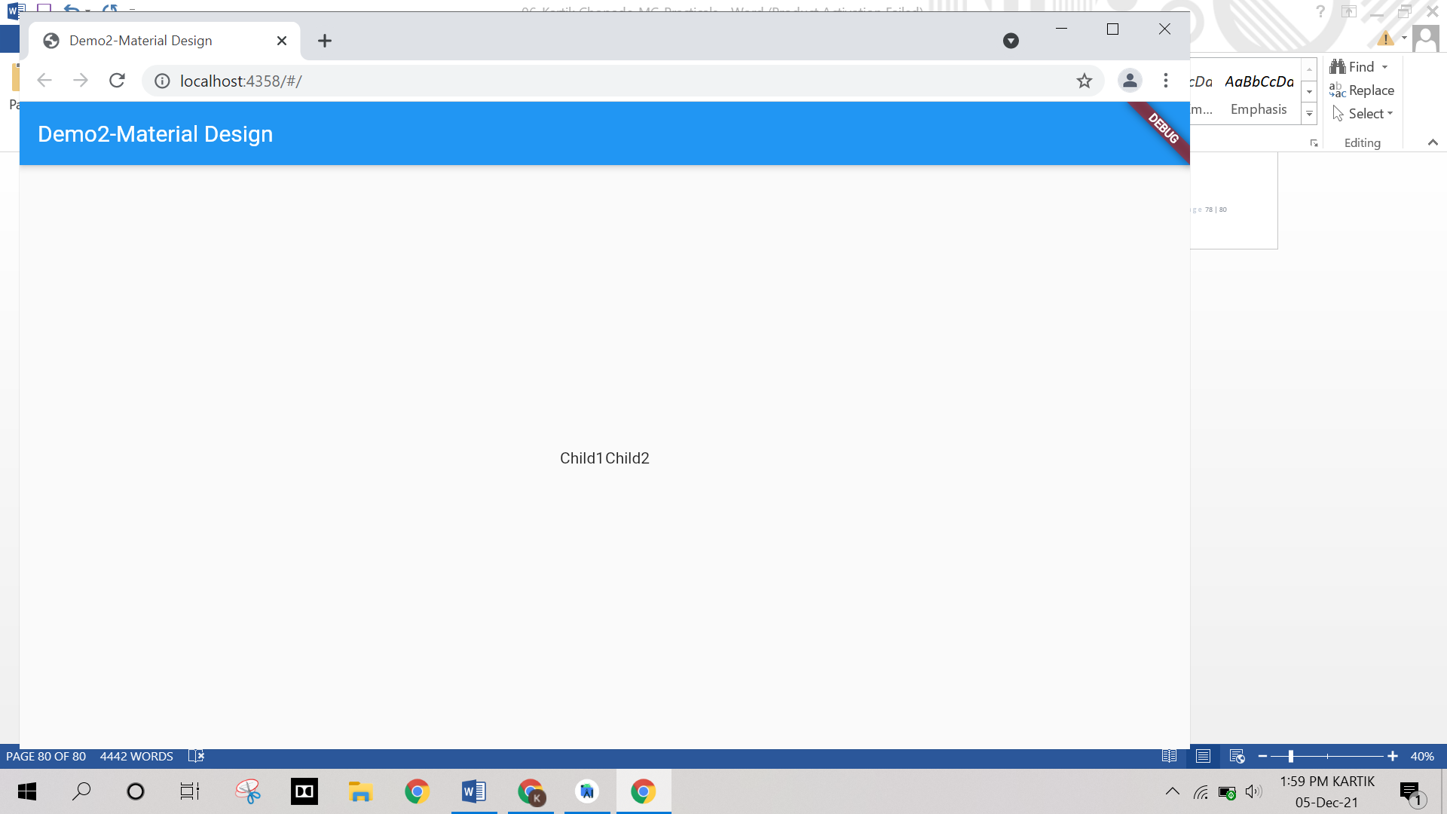

**Practical No. 26**

**Aim:** create flutter app to display login page using Stateful widget.

**Program:**

**Main.dart**

import 'package:flutter/material.dart';  
void main() {  
 runApp(MyApp());  
}  
Widget textsection=Column(  
children: const [  
Padding(  
padding: EdgeInsets.all(10),  
child: TextField(  
decoration: InputDecoration(  
border: OutlineInputBorder(),  
labelText: 'User Name',  
hintText: 'Enter valid mail id as abc@gmail.com'  
),  
),  
),  
Padding(  
padding: EdgeInsets.all(10),  
child: TextField(  
obscureText: true,  
decoration: InputDecoration(  
border: OutlineInputBorder(),  
labelText: 'Password',  
hintText: 'Enter your secure password'  
),  
),  
),  
]  
);  
Widget imagesection=Column( children:  
[Image.asset('image/login.jpg',  
 width:150,  
 height:150,  
 fit:BoxFit.cover,  
),  
],  
);  
class MyApp extends StatelessWidget {  
 @override  
 Widget build(BuildContext context) {  
 return MaterialApp(  
 title: 'Demo6-Layout-Advance',  
 home: Scaffold (  
 appBar: AppBar(  
 title: Text('Login-Page'),  
 ),  
 body:Column( children: [  
 imagesection, textsection,  
 Column( children: [  
 FlatButton( onPressed: (){  
 },  
 child: const Text(  
 'Forgot Password', style: TextStyle(color:  
 Colors.*blue*, fontSize: 15),  
 ),  
 ),  
 Container( height: 50,  
 width: 250, decoration:  
 BoxDecoration(  
 color: Colors.*blue*,  
 borderRadius: BorderRadius.circular(20)),  
 child: FlatButton( onPressed: () {  
 },  
 child: const Text( 'Login', style:  
 TextStyle(color: Colors.*white*, fontSize: 25),  
 ),  
 ),  
 ),  
 ],  
 ),  
 ],  
 )  
 ),  
 );  
 throw UnimplementedError();  
 }  
}

**Output:**

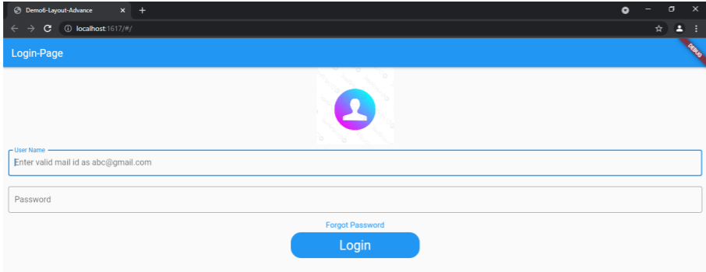

**Practical No. 27**

**Aim:** Create a flutter app for flutter navigation.

**Program:**

**Main.dart**

import 'package:flutter/material.dart';  
*//import 'Home.dart';*void main() {  
 runApp(MaterialApp(  
 title: 'Flutter Navigation',  
 theme: ThemeData(  
 *// This is the theme of your application.* primarySwatch: Colors.*green*,  
 ),  
 home: FirstRoute(),  
 ));  
}  
class FirstRoute extends StatelessWidget {  
 const FirstRoute({Key? key}) : super(key: key);  
 @override  
 Widget build(BuildContext context) {  
 return Scaffold(  
 appBar: AppBar(  
 title: Text('First Screen'),  
 ),  
 body: Center(  
 child: RaisedButton(  
 child: Text('Click Here'),  
 color: Colors.*orangeAccent*,  
 onPressed: () {  
 Navigator.*push*(  
 context,  
 MaterialPageRoute(builder: (context) => SecondRoute()),  
 );  
 },  
 ),  
 ),  
 );  
 }  
}  
class SecondRoute extends StatelessWidget {  
 @override  
 Widget build(BuildContext context) {  
 return Scaffold(  
 appBar: AppBar(  
 title: Text("Second Screen"),  
 ),  
 body: Center(  
 child: RaisedButton(  
 color: Colors.*blueGrey*,  
 onPressed: () {  
 Navigator.*pop*(context);  
 },  
 child: Text('Go back'),  
 ),  
 ),  
 );  
 }  
}

**Output:**

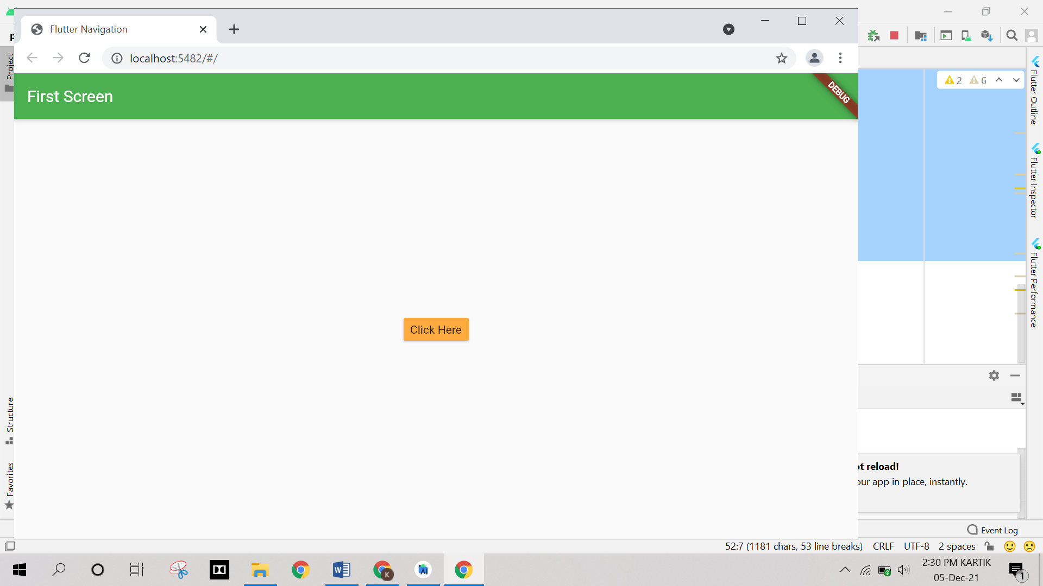

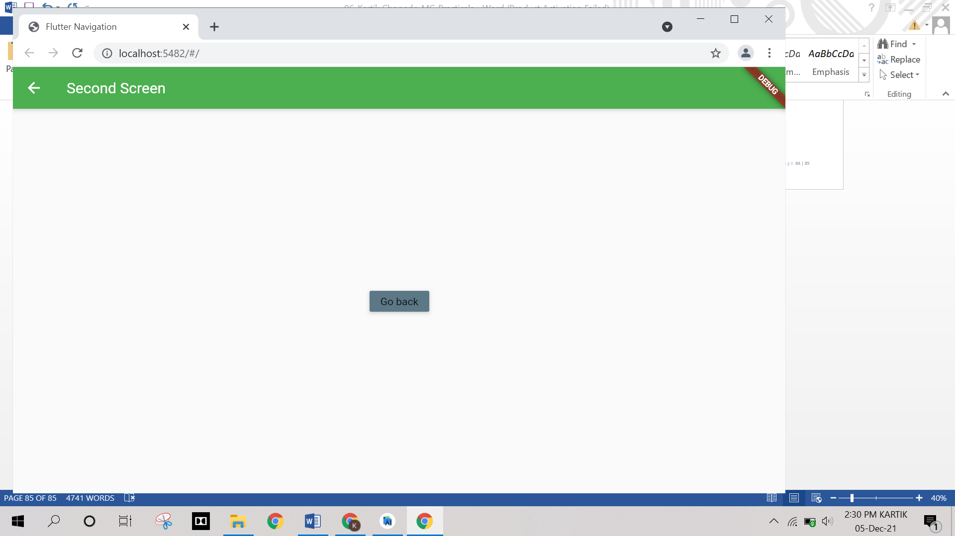

**Practical No. 28**

**Aim:** Create a flutter app to display a form

**Program:**

**Main.dart**

import 'package:flutter/material.dart';  
void main() => runApp(MyApp());  
class MyApp extends StatelessWidget {  
 @override  
 Widget build(BuildContext context) {  
 final appTitle = 'Flutter Form';  
 return MaterialApp(  
 title: appTitle,  
 home: Scaffold(  
 appBar: AppBar(  
 title: Text(appTitle),  
 ),  
 body: MyCustomForm(),  
 ),  
 );  
 }  
}  
*// Create a Form widget.*class MyCustomForm extends StatefulWidget {  
 @override  
 MyCustomFormState createState() {  
 return MyCustomFormState();  
 }  
}  
*// Create a corresponding State class, which holds data related to the form.*class MyCustomFormState extends State<MyCustomForm> {  
 *// Create a global key that uniquely identifies the Form widget  
 // and allows validation of the form.* final _formKey = GlobalKey<FormState>();  
 @override  
 Widget build(BuildContext context) {  
 *// Build a Form widget using the _formKey created above.* return Form(  
 key: _formKey,  
 child: Column(  
 crossAxisAlignment: CrossAxisAlignment.start,  
 children: <Widget>[  
 TextFormField(  
 decoration: const InputDecoration(  
 icon: const Icon(Icons.*person*),  
 hintText: 'Enter your full name',  
 labelText: 'Name',  
 ),  
 validator: (value) {  
 if (value!.isEmpty) {  
 return 'Please enter some text';  
 }  
 return null;  
 },  
 ),  
 TextFormField(  
 decoration: const InputDecoration(  
 icon: const Icon(Icons.*phone*),  
 hintText: 'Enter a phone number',  
 labelText: 'Phone',  
 ),  
 validator: (value) {  
 if (value!.isEmpty) {  
 return 'Please enter valid phone number';  
 }  
 return null;  
 },  
 ),  
 TextFormField(  
 decoration: const InputDecoration(  
 icon: const Icon(Icons.*calendar_today*),  
 hintText: 'Enter your date of birth',  
 labelText: 'Dob',  
 ),  
 validator: (value) {  
 if (value!.isEmpty) {  
 return 'Please enter valid date';  
 }  
 return null;  
 },  
 ),  
 new Container(  
 padding: const EdgeInsets.only(left: 150.0, top: 40.0),  
 child: new RaisedButton(  
 child: const Text('Submit'),  
 onPressed: () { *// It returns true if the form is valid, otherwise returns false* if (_formKey.currentState!.validate()) {  
 *// If the form is valid, display a Snackbar.* Scaffold.*of*(context)  
 .showSnackBar(SnackBar(content: Text('Data is in processing.')));  
 }  
 },  
 )),  
 ],  
 ),  
 );  
 }  
}

**Output:**

